**Instituto Tecnológico y de Estudios Superiores de Monterrey**

### Interconexión de dispositivos

**Competencia a desarrollar**: Diseñar esquemas de sub redes de manera eficiente para satisfacer las restricciones de conectividad de una organización.

Ejercicios con sub redes.

1. Utiliza la dirección IP **51.0.0.0** y un prefijo de red de /12 bits, responde a las siguientes preguntas:
2. Para esta dirección IP, ¿A qué clase pertenece esta dirección de red?
3. Para este esquema de subneteo, ¿Cuántos bits se han tomado prestados para crear subredes? y

¿Cuántos bits se han dedicado para la parte de hosts?

1. ¿Cuál es el valor de la máscara en notación punto decimal para este esquema de subneteo? . ._ .
2. Utilizando la dirección IP **121.0.0.0** y un prefijo de red de /25 bits, responde a las siguientes preguntas:
3. Para esta dirección IP, ¿A qué clase pertenece esta dirección de red?
4. Para este esquema de subneteo, ¿Cuántos bits se han tomado prestados para crear subredes? y

¿Cuántos bits se han dedicado para la parte de hosts?

1. ¿Cuál es el valor de la máscara en notación punto decimal para este esquema de subneteo? . ._ .
2. Utilizando la dirección IP **199.10.6.0** y un prefijo de red de /29 bits, responde a las siguientes preguntas:
3. Para esta dirección IP, ¿A qué clase pertenece esta dirección de red?
4. Para este esquema de subneteo, ¿Cuántos bits se han tomado prestados para crear subredes? y

¿Cuántos bits se han dedicado para la parte de hosts?

1. ¿Cuál es el valor de la máscara en notación punto decimal para este esquema de subneteo? . ._ .
2. Utilizando la dirección IP **172.168.0.0** y un prefijo de red de /26 bits, responde a las siguientes preguntas:
3. Para esta dirección IP, ¿A qué clase pertenece esta dirección de red?
4. Para este esquema de subneteo, ¿Cuántos bits se han tomado prestados para crear subredes? y

¿Cuántos bits se han dedicado para la parte de hosts?

1. ¿Cuál es el valor de la máscara en notación punto decimal para este esquema de subneteo? ._ ._ .
2. Utilizando la dirección IP **129.16.0.0** y un prefijo de red de /24 bits, responde a las siguientes preguntas:
3. Para esta dirección IP, ¿A qué clase pertenece esta dirección de red?
4. ¿Cuál es el valor de la máscara en notación punto decimal para este esquema de subneteo? . ._ .
5. Utiliza la dirección IP **10.0.0.0** y responde a las siguientes preguntas:
6. Para esta dirección IP, ¿Cuál es la dirección IP Broadcast de la red?
7. Si se desea tener por lo menos 8,190 direcciones IP válidas por cada subred, ¿Cuál deberá ser la máscara de red, en notación punto decimal, para este esquema de direccionamiento?
8. Tomando en cuenta la pregunta anterior, ¿Cuántos bits se deben tomar prestados para crear subredes? Con este número de bits prestados, ¿Cuántas subredes (en total) se pueden utilizar?
9. ¿Cuál es el valor del prefijo para este esquema de direccionamiento?
10. Utilizando los siguientes datos **IP 151.25.0.0** / **27** responde a la pregunta:

### ¿Cuál será el valor de la máscara en notación punto decimal para este esquema de direccionamiento?

1. Utiliza la dirección **IP 192.168.1.0** con un prefijo original de **/24** y toma los bits que sean necesarios para crear un esquema de direccionamiento de 4 subredes.

|  |  |  |  |  |
| --- | --- | --- | --- | --- |
| # Subred | Dir.IP Inicial | Primera IP Asignable | Última IP Asignable | Dir. IP Broadcast |
|  |  |  |  |  |
|  |  |  |  |  |
|  |  |  |  |  |
|  |  |  |  |  |
|  |  |  |  |  |

1. Utiliza la dirección **IP 221.16.79.0** con un prefijo original de /**24** y toma los bits que sean necesarios para crear un esquema de direccionamiento de 8 subredes.

|  |  |  |  |  |
| --- | --- | --- | --- | --- |
| # Subred | Dir.IP Inicial | Primera IP Asignable | Última IP Asignable | Dir. IP Broadcast |
|  |  |  |  |  |
|  |  |  |  |  |
|  |  |  |  |  |
|  |  |  |  |  |
|  |  |  |  |  |
|  |  |  |  |  |
|  |  |  |  |  |
|  |  |  |  |  |
|  |  |  |  |  |

1. Utiliza la dirección **IP 172.16.0.0/16** y toma los bits que sean necesarios para crear un esquema de direccionamiento de 4 subredes.

|  |  |  |  |  |
| --- | --- | --- | --- | --- |
| # Subred | Dir.IP Inicial | Primera IP Asignable | Última IP Asignable | Dir. IP Broadcast |
|  |  |  |  |  |
|  |  |  |  |  |
|  |  |  |  |  |
|  |  |  |  |  |
|  |  |  |  |  |

1. Utiliza la dirección **IP 10.0.0.0/8** y toma los bits que sean necesarios para crear un esquema de direccionamiento de 4 subredes.

|  |  |  |  |  |
| --- | --- | --- | --- | --- |
| # Subred | Dir.IP Inicial | Primera IP Asignable | Última IP Asignable | Dir. IP Broadcast |
|  |  |  |  |  |
|  |  |  |  |  |
|  |  |  |  |  |
|  |  |  |  |  |
|  |  |  |  |  |

1. Nuestra labor es realizar un diseño de subredes del siguiente diseño de red y asignar direcciones IPv4 a cada equipo terminal y cada interface del router. La dirección IP de red que hemos recibido para realizar el diseño lógico de la red es **192.168.10.0** con una prefijo de red original de /24. Además de las subredes que requieren para las interfaces del router, se desea contar con tres subredes adicionales para futuro crecimiento.

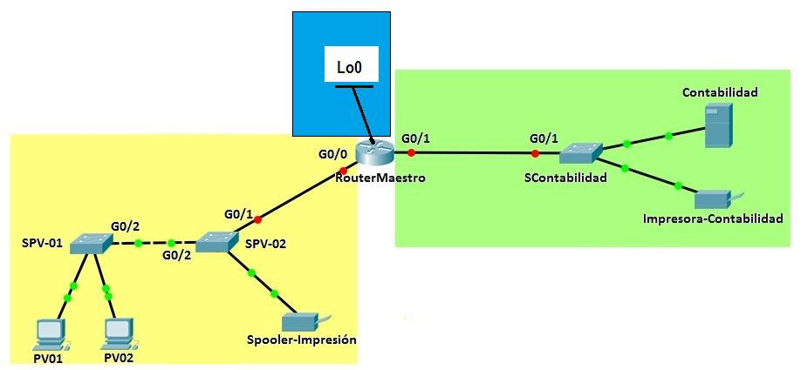

Para dar servicio a este diseño físico de red y tomando en consideración el crecimiento a futuro ¿cuántas redes necesitamos utilizar? ¿Cuántas subredes, como mínimo, debemos crear? ¿Cuántos bits deben de tomarse prestados de la porción de hosts para crear este diseño lógico de la red? ¿Cuántos direcciones IP de hosts hay por subred?

Utiliza la información del diseño lógico de red para realizar la asignación de dirección IPv4, máscaras de subneteo y default Gateway (en los casos que aplique) de cada equipo indicado en la tabla.

|  |  |  |  |  |
| --- | --- | --- | --- | --- |
| **Device** | **Interface** | **IP Address** | **Subnet Mask** | **Default Gateway** |
| **RouterMaestro** | **G0/0** |  |  | N/A |
|  | **G0/1** |  |  | N/A |
|  | **Lo0** |  |  | N/A |
| **PV01** | **NIC** |  |  |  |
| **PV02** | **NIC** |  |  |  |
| **PV03** | **NIC** |  |  |  |
| **Spooler-Impresión** | **NIC** |  |  |  |
| **Impresora-Contabilidad** | **NIC** |  |  |  |
| **Contabilidad** | **NIC** |  |  |  |

Nuestra tarea es crear un diseño de subredes apropiado para el siguiente diseño físico de red.

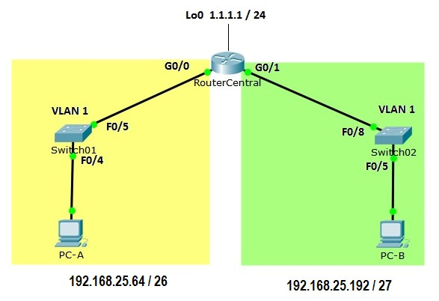

1. Utiliza el diseño lógico de red de la figura para escribir en cada línea de la tabla, las direcciones IP de las interfaces de los equipos de interconexión y su máscara en notación punto decimal y de acuerdo a lo que se indica en la siguiente tabla.

|  |  |  |  |  |
| --- | --- | --- | --- | --- |
| **Device** | **Interface** | **IP Address** | **Subnet Mask** | **Default Gateway** |
| **RouterCentral** | **G0/0** | Última IP válida de la subred | De acuerdo al diagrama | N/A |
|  |  |  |  |  |
|  | **G0/1** | Última IP válida de la subred | De acuerdo al diagrama | N/A |
|  |  |  |  |  |
|  | **Lo0** | 1.1.1.1 | 255.255.255.0 | N/A |
| **PC-A** | **NIC** | Tercera IP válida del bloque | De acuerdo al diagrama | La IP del G0/0 |
|  |  |  |  |  |
| **PC-B** | **NIC** | Quinta IP válida del bloque | De acuerdo al diagrama | La IP del G0/1 |
|  |  |  |  |  |

### Interconexión de Dispositivos

Objetivo: Diseñar esquemas de direccionamiento con VLSM para satisfacer las necesidades de conectividad de una organización.

El administrador de la red del corporativo **IT2 Networking Consulting** se ha percatado que al diseñar un esquema de direccionamiento con 4 bits prestados para crear 16 subredes no es la mejor estrategia para cumplir las restricciones de conectividad impuestas en cada red local (las subredes que se conectan de las interfaces **Giga Ethernet** de cada ruteador) de la gráfica, pues aunque las subredes son suficientes para este diseño, las direcciones IP disponibles para algunos de los bloques no sería el adecuado.

Por tal motivo, nos han solicitado apoyo para diseñar un esquema de direccionamiento de máscaras de longitud variable (**VLSM**) que haga un uso óptimo de las direcciones IP disponibles y que permita cumplir con las restricciones de conectividad de la red.

La topología del corporativo y las necesidades de conectividad están representadas en la siguiente gráfica.

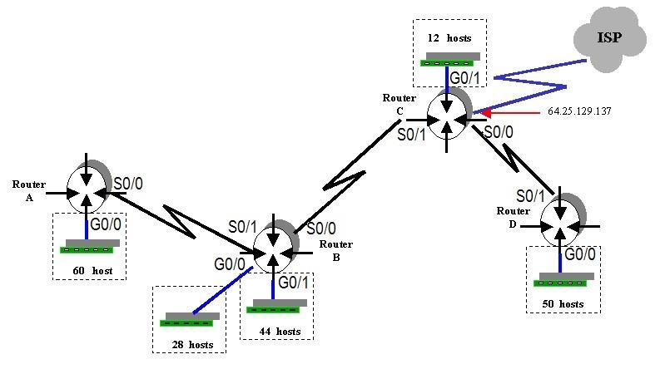

Observa que el número de hosts requeridos por cada **LAN** están indicados en la gráfica. Por ejemplo: la red local que depende de la interfaz **G0/0** del **Router A** requiere de 60 conexiones disponibles mientras que la red que depende de la interfaz **G0/1** del **Router C** necesita solo de 12 direcciones **IP** disponibles. No olvides que las interfaces **GigaEthernet** de cada router, para poder configurarla, también requieren de una dirección **IP** válida.

La dirección **IP** publica asignada al corporativo es **221.16.128.0** con un prefijo original de red **/24**.

¿Será este bloque de direcciones **IP** públicas suficiente para dar respuesta a las necesidades de conectividad del corporativo? ¿Cuántas subredes se requieren utilizar para este diseño de red?

Utiliza la información de la gráfica y con el número de hosts requeridos para cada una de las subredes de las interfaces Giga Ethernet, determina los prefijos de red para cada subred. No olvides que las interfaces seriales de los ruteadores también requieren de una dirección IP válida.

Diseña el esquema de direccionamiento con máscaras de longitud variable y completa la tabla con la información que se solicita escribiendo en cada renglón (exclusivamente notación punto decimal) las direcciones IP que asignarás a cada una de las interfaces y la máscara correspondiente (también en notación punto decimal).

|  |  |  |  |  |
| --- | --- | --- | --- | --- |
| Router | S0/0 | S0/1 | G 0/0 | G 0/1 |
| A | ------------------- | No se usa  -------------------  No se usa | --------------------------- | No se usa  -------------------  No se usa |
| B | --------------------------- | --------------------------- | --------------------------- | ------------------------- |
| C | --------------------------- | ------------------------- | No se usa  -------------------  No se usa | ---------------------- |
| D | No se usa  -------------------  No se usa | --------------------------- | --------------------------- | No se usa  -------------------  No se usa |

**Competencia Disciplinar:** Configura el equipo requerido que permite la operación de una red de cobertura local que satisface las necesidades de organizaciones pequeñas identificando diferentes opciones de infraestructura tecnológica

Una tienda de conveniencia nos ha contratado para realizar la configuración de Switches, Routers y Equipos Terminales de una nueva sucursal.

Nuestra labor es realizar las configuraciones de todos los equipos para tener comunicación entre las estaciones del siguiente diseño de red y dejar preparada la infraestructura de red para conectarnos en un futuro con el **ISP**.

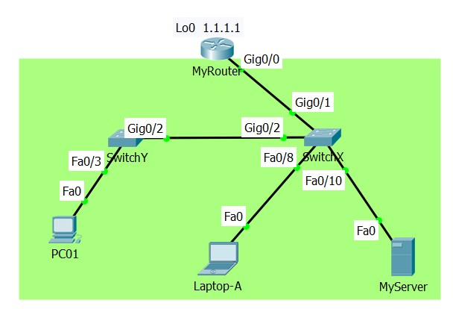

Utiliza la información de la siguiente tabla para realizar la configuración solicitada de cada equipo

|  |  |  |  |  |
| --- | --- | --- | --- | --- |
| **Dispositivo** | **Interfaz** | **IP Address** | **Máscara de subneteo** | **Default Gateway** |
| **MyRouter** | **G0/0** | 192.168.10.254 | 255.255.255.0 | N/A |
|  | **Lo0** | 1.1.1.1 | 255.255.255.0 | N/A |
| **SwitchX** | **VLAN 1** | 192.168.10.1 | 255.255.255.0 | 192.168.10.254 |
| **SwitchY** | **VLAN 1** | 192.168.10.200 | 255.255.255.0 | 192.168.10.254 |
| **PC01** | **NIC** | 192.168.10.10 | 255.255.255.0 | 192.168.10.254 |
| **Laptop-A** | **NIC** | 192.168.10.20 | 255.255.255.0 | 192.168.10.254 |
| **MyServer** | **NIC** | 192.168.10.30 | 255.255.255.0 | 192.168.10.254 |

Para realizar la configuración de cada dispositivo de la red y lograr la conectividad deseada, se sugiere proceder con el siguiente orden:

* 1. Realizar la configuración del switch **SwitchX** de acuerdo a la siguiente secuencia de pasos**:** a) Establecer como nombre del equipo **SwitchX**, b) Establecer fecha y hora del día de hoy, c) Configurar un **banner** de prevención de acceso al switch, d) Establecer el servicio de cifrado de passwords, e) Establecer **class** como password del enable, f) Establecer password **cisco** al **line console 0** y habilitar **login**, g) Establecer **cisco** al password de la **line vty** 0 15 y habilitar **login**, h) Configurar la **IP** y la **máscara de subneteo** (de acuerdo a los datos de la tabla) a la interfaz virtual **VLAN 1** y encender la interfaz, i) Establecer la puerta enlace predeterminada con la dirección IP indicada en la tabla.
  2. Realizar la configuración de todos los equipos terminales que están directamente conectados al **SwitchX**

y realiza las pruebas de conectividad necesarias entre los equipos interconectados por este switch.

**Nota**: Las pruebas de conectividad deben ser exitosas.

* 1. Realizar la configuración del switch **SwitchY** de acuerdo a la siguiente secuencia de pasos**:** a) Establecer como nombre del equipo **SwitchY**, b) Establecer fecha y hora del día de hoy, c) Configurar un **banner** de prevención de acceso al switch, d) Establecer el servicio de cifrado de passwords, e) Establecer **class** como password del enable, f) Establecer password **cisco** al **line console 0** y habilitar **login**, g) Establecer **cisco** al password de la line **vty** 0 15 y habilitar **login**, h) Configurar la **IP** y la **máscara de subneteo** (de acuerdo a los datos de la tabla) a la interfaz virtual **VLAN 1** y encender la interfaz, i) Establecer la puerta enlace predeterminada con la dirección IP indicada en la tabla.
  2. Realizar la configuración de todos los equipos terminales que están directamente conectados al **SwitchY**

y realiza las pruebas de conectividad necesarias entre los equipos interconectados por este switch.

**Nota**: Las pruebas de conectividad deben ser exitosas.

* 1. Realizar la configuración del router **MyRouter** de acuerdo a la siguiente secuencia de pasos**:** a) Establecer como nombre del equipo **MyRouter**, b) Establecer fecha y hora del día de hoy, c) Configurar un **banner** de prevención de acceso al switch, d) Establecer el servicio de cifrado de passwords, e) Establecer **class** como password del enable, f) Establecer password **cisco** al **line console 0** y habilitar **login**, g) Establecer **cisco** al password de la Line **vty** 0 4 y habilitar **login**, h) Configurar la **IP** y la **máscara de subneteo** (de acuerdo a los datos de la tabla) a la interfaz **Giga Ethernet 0/0 (G0/0)** y encender la interfaz, i) Configurar la **IP** y la **máscara de subneteo** (de acuerdo a los datos de la tabla) a la interfaz **LoopBack 0 (Lo0)** y encender la interfaz.

Pruebas de conectividad generales para comprobar el funcionamiento correcto de las configuraciones

Desde la **PC01** utiliza la aplicación **Telnet** y accede a la dirección **IP** del **SwitchX (192.168.10.1)**. Utiliza password **cisco** y **class** para acceder a modo de configuración del switch. Si el telnet es exitoso, la configuración está correcta.

Realiza la misma prueba del **Telnet** con la dirección IP de **SwitchY (192.168.10.200)**.

Finalmente, desde la PC01 realiza un ping a la dirección **1.1.1.1** (Loopback que, para nuestro caso, está simulando ser el **ISP**)

**Competencia Disciplinar:** Configura el equipo requerido que permite la operación de una red de cobertura local que satisface las necesidades de organizaciones pequeñas identificando diferentes opciones de infraestructura tecnológica

Los espacios de coworking o espacios de trabajo colaborativo son instalaciones de trabajo que varias personas comparten con el fin de mejorar su productividad, hacer networking e inclusive reducir los costos de servicios y renta de un espacio físico.

El coworking se ha vuelto una gran oportunidad de negocio en México y otros países ya que representa una opción favorable para pequeñas empresas, startups y freelancers [1]. Un ejemplo de estos negocios es **COHAUS**, un espacio de coworking que ofrece desde espacios libres de trabajo y escritorios fijos, hasta salas de juntas y oficinas bien equipadas. [2]

Vamos a considerar el equipo de red de un negocio de coworking. Cada pieza de infraestructura pertenece al segmento de **administradores** o al segmento de **usuarios**. El primer segmento está dedicado al personal del establecimiento y está constituido de no más de 18 equipos terminales. Entre estos equipos están: un servidor local, un teléfono IP, una impresora, una cámara web, un punto de venta y una PC para el administrador (manager). Las direcciones IP de los equipos terminales se asignan de manera estática (manualmente).

Mientras tanto, en el segmento de **usuarios** simplemente se encuentran los equipos personales conectados físicamente a la red. En este segmento de red hay un máximo de 100 equipos a conectar. La asignación de direcciones IP a los equipos del segmento de usuarios se realiza por **DHCP**.

Ahora te queda como reto, diseñar y configurar los equipos de interconexión de la red usando el simulador de Packet Tracer.

**Referencias**

[1] Solís, A. (2018). *Guía Forbes de Coworking: todo lo que necesitas saber*. Recuperado de <https://www.forbes.com.mx/guia-forbes-de-coworking-todo-lo-que-necesitas-saber/>

### [2] COHAUS. (s.f.). *Paquetes*. Recuperado de <https://cohaus.work/paquetes/>

Utiliza la aplicación del PacketTracer de CISCO y la gráfica incluida en este documento para realizar: (a) la configuración del router y switches (b) la instalación del servicio de DHCP para asignar direcciones a los equipos terminales del segmento usuarios, (c) las pruebas de conectividad necesarias y que permitan verificar la configuración correcta de los equipos de interconexión, de los equipos terminales y de los servicios de Telnet en el router y los switches.

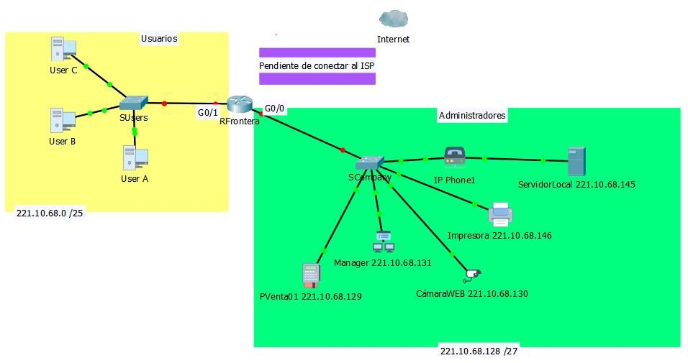

Diseño físico de la red.

La dirección IP a utilizar para realizar la configuración de los equipos de interconexión y la configuración de cada equipo terminal, es **221.10.68.0** con prefijo original de red **/24**.

El **VLSM** calculado con base en la descripción de equipos terminales que se requieren conectar en cada segmento de red está indicado en la siguiente tabla.

|  |  |  |  |  |  |
| --- | --- | --- | --- | --- | --- |
| **Requisitos de Conectividad** | **Prefij o Red** | **IP Bloque** | **Máscara** | **Primera IP válida** | **Última IP válida** |
| **Usuarios 100 hosts** | **/25** | **221.10.68.0** | **255.255.255.128** | **221.10.68.1** | **221.10.68.126** |
| **Administradores 18 hosts** | **/27** | **221.10.68.128** | **255.255.255.224** | **221.10.68.129** | **221.10.68.158** |

* + 1. Asigna y escribe en cada línea de la tabla, las direcciones IP de las interfaces de los equipos de interconexión, su máscara en notación punto decimal y de conforme a lo que se indica en la siguiente tabla.

|  |  |  |  |  |
| --- | --- | --- | --- | --- |
| **Device** | **Interface** | **IP Address** | **Subnet Mask** | **Default Gateway** |
| **RFrontera** | **G0/0** | Última IP válida de la subred |  | N/A |
|  | **G0/1** | Última IP válida de la subred |  | N/A |
|  | **Lo0** | **1.1.1.1** | **255.255.255.224** | N/A |
| **SUsers** | **VLAN 1** | Penúltima IP válida de la subred |  |  |
| **SCompany** | **VLAN 1** | Penúltima IP válida de la subred |  |  |
| **User A** | **NIC** | **Asignada por DHCP** | **Asignada por DHCP** | **Asignada por DHCP** |
| **User B** | **NIC** | **Asignada por DHCP** | **Asignada por DHCP** | **Asignada por DHCP** |
| **User C** | **NIC** | **Asignada por DHCP** | **Asignada por DHCP** | **Asignada por DHCP** |
| **PVenta01** | **NIC** | **221.10.68.129** | **255.255.255.224** | **221.10.68.158** |
| **CámaraWEB** | **NIC** | **221.10.68.130** | **255.255.255.224** | **221.10.68.158** |
| **Manager** | **NIC** | **221.10.68.131** | **255.255.255.224** | **221.10.68.158** |
| **ServidorLocal** | **NIC** | **221.10.68.145** | **255.255.255.224** | **221.10.68.158** |
| **Impresora** | **NIC** | **221.10.68.146** | **255.255.255.224** | **221.10.68.158** |

* + 1. Realiza la configuración de las interfaces del **Router Frontera**. Deshabilitar el **DNS**. Asignar password **cisco** al Line Console 0. Asignar **class** como password del enable. Hostame **RFrontera**. Configurar un **banner** de prevención de acceso al router. Asignar **cisco** al password de la Line Vty 0 4.
    2. Realiza la configuración del switch **SUsers**. Deshabilitar el **DNS**. Asignar password **cisco** al Line Console 0. Asignar **class** como password del enable. Hostame **SUsers**. Configurar un **banner** de prevención de acceso al router. Asignar cisco al password de la Line Vty 0 15. Configurar la **VLAN1** con los datos de la tabla y el **default Gateway** de este switch.
    3. Realiza la configuración del switch **SCompany**. Deshabilitar el **DNS**. Asignar password **cisco** al Line Console 0. Asignar **class** como password del enable. Hostame **SCompany**. Configurar un **banner** de prevención de acceso al router. Asignar cisco al password de la Line Vty 0 15. Configurar la **VLAN1** con los datos de la tabla y el **default Gateway** de este switch.
    4. Utiliza la información de la tabla y configura manualmente la dirección IP, máscara y puerta de enlace predeterminada para cada equipo terminal del segmento de **administradores**.

Para comprobar la configuración realizada, ejecuta un ***ping*** desde los equipos terminales **User A** y **User C** del diseño de red, a la dirección IP de la interfaz **LoopBack 0** del router frontera. Si el *ping* es exitoso, tu configuración en ese segmento de red está correcta. En caso contrario, deberás encontrar y corregir la falla.

Desde la **User A** y **User B** utiliza la aplicación **Telnet** y accede a la dirección IP del **switch SUsers** y **SAdministradores**. Utiliza password **cisco** y **class** para acceder a modo de configuración del switch. Si el **Telnet** es exitoso, la configuración está correcta. En caso contrario, deberás encontrar y corregir la falla.

### Desde **User C** utiliza el navegador **web** de la terminal y utilizado la dirección IP del server **accede** al **ServidorLocal** y utiliza la IP de la cámara para acceder, con el navegador web de la terminal, al servidor **CámaraWEB**. Si el acceso a los servidores es exitoso, tu configuración es correcta. En caso contrario, deberás encontrar y corregir la falla.

Agrega imágenes (impresión de pantalla) de las pruebas de conectividad realizadas.

Mariand Castrejón Castañeda, mejor conocida en las redes sociales como Yuya, cuenta con más de 23 millones de suscriptores en su canal de Youtube, motivo por el cual , se cambiará a un estudio de producción más grande, debido a que tiene una gran carga de trabajo, y por ello requiere un espacio más amplio, para el cual necesitará contar con 3 cámaras de seguridad, 1 servidor, 3 impresoras de alta calidad, posibilidad de conectarse tanto alámbrica como inalámbricamente y una cafetera inteligente para cuando invite a su nuevo estudio a sus amigos o a su novio, el también Youtuber de Monterrey Beto Pasillas.

Utiliza la aplicación del PacketTracer de CISCO y las gráficas incluidas en este documento para realizar: (a) el diseño de red, (b) la configuración del router y switches (c) las pruebas de conectividad necesarias y que permitan verificar la configuración correcta de los equipos de interconexión, de los equipos terminales y de los servicios de Telnet en el router y los switches.

Nuestra tarea es crear un diseño de red apropiado y realizar las configuraciones para tener comunicación de las estaciones de la LAN a las direcciones de Internet (que en este caso la Internet está simulada por solo dos servers y tres direcciones IP adicionales).

**NOTA**: El router del ISP y los servidores en Internet ya están configurados y son funcionales. Para lograr la conectividad, se sugiere proceder con el siguiente orden:

1. Realiza el diseño de red de la página 4. Esta será la red a configurar. La dirección IP a utilizar para realizar el diseño de red, y la configuración de cada equipo, es **215.60.127.0** con prefijo original de red

**/24**.

|  |  |  |  |  |  |
| --- | --- | --- | --- | --- | --- |
| **Requisitos de Conectividad** | **Prefijo Red** | **IP Bloque** | **Máscara** | **Primera IP válida** | **Última IP válida** |
| **20 hosts para el Estudio** | **/27** |  |  |  |  |
| **6 hosts para la zona de servicios** | **/28** |  |  |  |  |

### Para contar con la información actualizada de este caso, asigna y escribe en cada línea de la siguiente tabla, las direcciones IP de las interfaces de los equipos de interconexión y su máscara en notación punto decimal que utilizarás tú la solución. Recuerda que esta información te ayudará a evitar duplicación de direcciones IP.

|  |  |  |  |  |
| --- | --- | --- | --- | --- |
| **Device** | **Interface** | **IP Address** | **Subnet Mask** | **Default Gateway** |
| **YuyasRouter** | **G0/0** |  |  | N/A |
|  | **G0/1** |  |  | N/A |
|  | **S0/0/0** | **132.254.255.253** | **255.255.255.252** | N/A |
| **SwitchStudio** | **VLAN 1** |  |  |  |
| **SwitchServicios** | **VLAN 1** |  |  |  |
| **YuyasServer** | **NIC** |  |  |  |
| **SecurityCam01** | **NIC** |  |  |  |
| **SecurityCam02** | **NIC** |  |  |  |
| **SecurityCam03** | **NIC** |  |  |  |
| **Printer1** | **NIC** |  |  |  |
| **Printer2** | **NIC** |  |  |  |
| **Yuya’s SmartPhone** | **NIC** |  |  |  |
| **Yuya´s Tablet** | **NIC** |  |  |  |
| **Printer0** | **NIC** |  |  |  |
| **Cafetera** | **NIC** |  |  |  |

1. Realizar la configuración de las interfaces del router. Deshabilitar el **DNS**. Asignar password **cisco** al Line Console 0. Asignar **class** como password del enable. Hostame **YuyasRouter**. Configurar un **banner** de prevención de acceso al router. Asignar **cisco** al password de la Line Vty 0 4.
2. Realizar la configuración del SwitchStudio. Deshabilitar el **DNS**. Asignar password **cisco** al Line Console 0. Asignar **class** como password del enable. Hostame **SwitchStudio**. Configurar un **banner** de prevención de acceso al router. Asignar cisco al password de la Line Vty 0 15.
3. Realizar la configuración del SwitchServicios. Deshabilitar el **DNS**. Asignar password **cisco** al Line Console 0. Asignar **class** como password del enable. Hostame **SwitchServicios**. Configurar un **banner** de prevención de acceso al router. Asignar cisco al password de la Line Vty 0 15.
4. Para interconectar la red local con el proveedor de servicio es necesario instalar una ruta estática por default. La ruta por default puede ser una ruta estática directamente conectada, una ruta estática recursiva o una ruta estática completamente conectada (full connected).

Instala, en el router, una ruta estática por default para completar la conexión con el ISP.

Para comprobar la configuración, utiliza el navegador WEB desde cada una de los equipos terminales (SmartPhone y Tablet), del diseño de red y utiliza la dirección IP de los servidores CNN.com y Youtube.com para acceder a los contenidos. Si se despliegan las páginas WEB correspondientes, tu configuración está correcta. En caso contrario, deberás corregir la falla.

Realiza pruebas de ping al resto de las direcciones IP publicadas en el diagrama de la red. Todos los pings deben ser exitosos. En caso contrario, deberás identificar y corregir la falla.

Agrega, imágenes de las pruebas de conexión entre dispositivos.

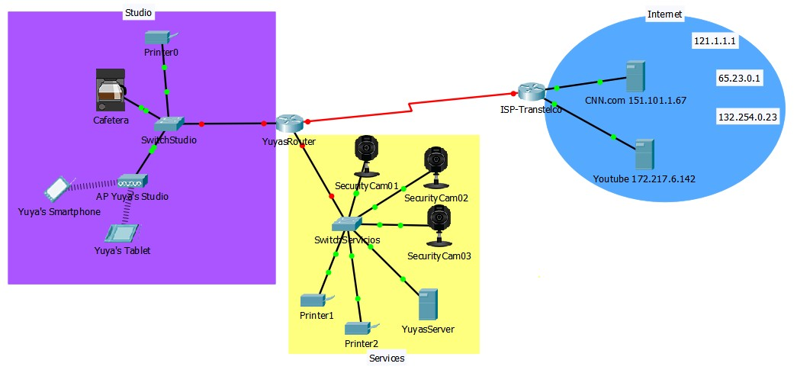

4

# Una compañía dedicada a la venta de soluciones de infraestructura computacional de servicios residenciales de Internet se ha acercado a las oficinas centrales de **IT2 Networking Consulting**, y solicitado nuestros servicios para diseñar un nuevo producto que responda de manera efectiva a las necesidades de conectividad residencial que actualmente imperan debido a la pandemia.

Hasta hace unos días, la compañía ofrecía al cliente un único producto estandarizado al ofrecer los servicios de conectividad utilizando un solo equipo (router inalámbrico) con 4 conexiones físicas de FastEthernet y acceso inalámbrico.

Después de la primera entrevista con el CEO y con el departamento de mercadotecnia de dicha compañía, el departamento de **Desarrollo de Nuevos Productos** de **IT2 Networking Consulting** nos hace la siguiente pregunta ¿Cómo podríamos hacer más eficiente el tráfico de la red local de una infraestructura residencial? ¿Qué tendríamos que hacer para segmentar el tráfico?

El departamento de **TI** de **IT2 Networking Consulting**, con base en la información recopilada nos solicita realizar una propuesta de solución.

# Nuestra labor del día de hoy es realizar la programación necesaria de los equipos de interconexión para demostrar que el tráfico puede ser segmentado utilizando VLANs.

Utiliza la propuesta inicial del diseño lógico de la red (segmentación de tráfico) de la siguiente tabla.

|  |  |  |  |  |
| --- | --- | --- | --- | --- |
| Segmento | VLAN | Puertos asignados | Dirección IP del bloque | Máscara de subred |
| Home Office | 10 | 1-15 | 192.168.10.0 | 255.255.255.128 |
| Entretenimiento | 20 | 16-24 | 192.168.10.128 | 255.255.255.192 |
| Gestión | 1 | No aplica | 192.168.10.252 | 255.255.255.252 |

La topología de la red y direcciones IP están representadas en la siguiente gráfica.

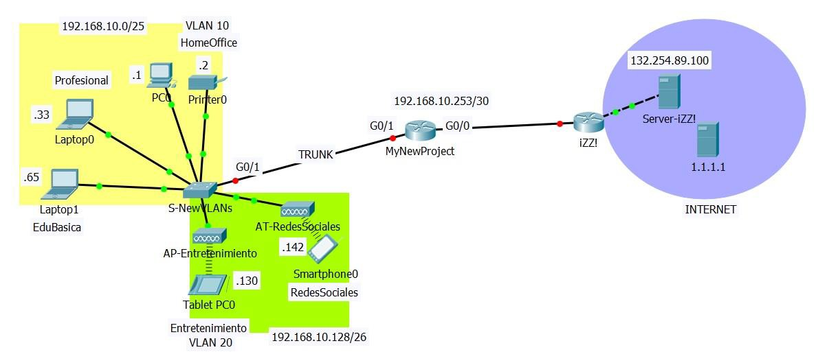

Utiliza toda la información que tienes disponible para concluir con la programación de todos los equipos de interconexión.



**AReferenceGuideTo:** ANSI/TIA/EIA-568-B ANSI/TIA/EIA-568-B.2-1 ANSI/TIA/EIA-568-B.2-ad10 ANSI/TIA/EIA-569-B ANSI/TIA/EIA-606-A

P r odu c t s . Te c hno l ogy . Se r v i c e s . De l i v e r e d Gl ob a l l y.

J-STD-607-A ANSI/TIA/EIA-942 IEEE802.3af IEEE802.3an IEEE802.11 ISO11801,ClassEA

StandardsReferenceGuide

Anixter:TheCabling SystemExperts



P r odu c t s . Te c hno l ogy . Se r v i c e s . De l i v e r e d Gl ob a l l y.

#### Anixteristheworld’sleadingsupplierofcommunication productsusedtoconnectvoice,video,dataandsecuritysystems. Anixterisalsotheleadingproviderofelectricalandelectronicwire andcable,fasteners,andothersmallcomponentstobuild,repair, andmaintainavarietyofsystemsandequipment.Webundle ourproductswithourinnovativeSupplyChainServicestocut costsoutofourcustomers’businessprocesses,andensure theyget therightproduct,thefirst time.

YoucanlooktoAnixterwhenyouneedanytypeofcommunication infrastructure.Whetheryou’relookingfordata,voiceorvideo networks,wiredorwireless,inanoffice,campusorfactory, Anixteristhecompanytoturnto.Wearetheonedistributor withboththetechnicalsavvytohelpyoudeterminetheright productsforyourapplicationandtheunparalleledglobal distributioncapabilitiestogetyouthatproduct,when andwhereyouneedit.Inaneffort tocontinuallysupport you,wehavepulledtogethersomevaluableinformation fromANSI/TIA/EIA, ISOandIEEE. Theinformationcontainedwithinthisreferenceguidecovers thekeyaspectsof theANSI/TIA/EIA-568-B,568-B.2-1,

568-B.2-ad10,569-B,606-A,J-STD-607-A,942,IEEE802.3af,

IEEE802.3an,IEEE802.11andISO11801standards. Wehopeyoufinditscontentsinformativeanduseful.

**Scopeof thisHandbook**

Thisdocumentismeantasareferencethathighlightsthekeypointsofthe ANSI/TIA/EIA-568-B,569-B,606-A,J-STD-607-A,942andIEEE802.3af,

IEEE802.3an,IEEE802.11andISO11801standards.Itisnotintendedas asubstitutefortheoriginaldocuments.Forfurtherinformationonanytopic intheguide,refertotheactualstandard.Seethesectioncalled“Reference Documents”forinstructionsonhowtoorderacopyofthestandarditself.

###### AbbreviationReferences:

ANSI AmericanNationalStandardsInstitute ASTM AmericanSocietyforTestingandMaterials CSA CanadianStandardsAssociation

EIA ElectronicIndustriesAlliance

IEC InternationalElectrotechnicalCommission IEEE InstituteofElectrical&ElectronicEngineers ISO InternationalOrganizationforStandardization NEC NationalElectricCode

NEMA NationalElectricalManufacturersAssociation NFPA NationalFireProtectionAssociation

TIA TelecommunicationsIndustryAssociation

StandardsReferenceGuide |3

**TableofContents**

ANSI/TIA/EIA-568-B,CommercialBuilding TelecommunicationsCablingStandard 5

568-B.1,GeneralRequirements 8

568-B.2,BalancedTwistedPairCablingComponents 21

568-B.2-1,Category6TransmissionPerformance 26

TIA/EIA-568-B.2-Addendum10,AugmentedCat6 TransmissionPerformance 32

TIA/EIA-568-B.3,OpticalFiberCablingComponents 34

ANSI/TIA/EIA-569-B,PathwaysandSpaces 36

ANSI/TIA/EIA-606-A,Administration 49

J-STD-607-A,GroundingandBonding 60

ANSI/TIA/EIA-942 64

PurposeoftheISO11801:2002Standard 73

ISO11801,ClassEA 74

IEEE802.3afPoweroverEthernet 75

IEEE802.11Wireless 76

IEEE802.3an 78

AnixterEnterpriseCablingandSecurityLabs 80

ReferenceDocuments 84

**Purposeof theANSI/TIA/EIA-568-BStandard**

##### ThePurpose:

• Establishagenerictelecommunicationscablingstandard thatwillsupportamultivendorenvironment

• Enabletheplanningandinstallationofastructured cablingsystemforcommercialbuildings

• Establishperformanceandtechnicalcriteria forvariouscablingsystemconfigurations

##### TheStandardSpecifies:

• Minimumrequirementsfortelecommunications cablingwithinanofficeenvironment

• Recommendedtopologyanddistances

• Mediaparameterswhichdetermineperformance

• Connectorandpinassignmentstoensureinterconnectability

• Theuseful lifeoftelecommunicationscablingsystems asbeinginexcessof10years

Buildingtelecommunicationscablingspecifiedbythisstandardisintended tosupportawiderangeofdifferentcommercialbuildingsitesand applications(e.g.,voice,data,text,videoandimage).Typically,thisrange includessiteswithageographicalextentfrom10,000to10,000,000sqft (3,000-1,000,000m2)ofofficespace,andwithapopulationofupto 50,000individualusers.

ThisstandardreplacesANSI/TIA/EIA-568-AdatedOctober6,1995. ThisstandardalsoincorporatesandrefinesthetechnicalcontentofTSB67, TSB72,TSB75,TSB95andTIA/EIA-568-A-1,A-2,A-3,A-4andA-5.

P

r o d u c t s

.

T

e c h n o

l o g y

.

S

e r v i c e s

.

D

e l i v

e r e d

G

l o b a l l y

.

StandardsReferenceGuide |5

Fo r mo r e i n f o rma t i on , v i s i t [www.](http://www/) a n i x t e r . c om o r c a l l 1 . 800 . An i x t e r .

4| StandardsReferenceGuide

SectionContents

**ANSI/TIA/EIA-568-B**

CommercialBuildingTelecommunicationsCablingStandard TIA/EIA-568-B.1GeneralRequirements

TheSixSubsystemsofaStructuredCablingSystem 8

EntranceFacilities 8

EquipmentRoom................................................... 8

BackboneCabling .................................................. 9

DesignRequirements 10

TelecommunicationsRoom 11

HorizontalCabling .................................................. 11

SpecifiedTopology.................................................. 11

MaximumDistances 12

MUTOA............................................................ 12

ConsolidationPoint 13

CentralizedOpticalFiber 14

WorkArea ........................................................ 15

WorkAreaComponents 15

TelecommunicationsOutlet 15

1. PositionModularJackPairAssignments 16

ChannelandPermanentLink 16

DefinitionsofElectricalParameters 18

TIA/EIA-568-B.2BalancedTwistedPairCablingComponents 100OhmUnshieldedTwistedPairCablingSystems 21

HorizontalandBackboneCable 21

BundledandHybridCable 23

UTPConnectingHardware 23

UTPPatchCords.................................................... 24

TIA/EIA-568-B.2-1BalancedTwistedPairCablingComponents Category6TransmissionPerformance 26

HorizontalandBackboneCable 27

ConnectingHardware 28

AssembledPatchCords 29

PermanentLink .................................................... 30

Channel........................................................... 30

LongitudalConversionLoss 31

TIA/EIA-568-B.2-ad10BalancedTwistedPairCablingComponents AugmentedCategory6PermanentLinkRequirements 32

AugmentedCategory6ChannelRequirements 33

TIA/EIA-568-B.3OpticalFiberCablingComponents

OpticalFiberCabling 34

OpticalFiberBendRadius 34

OpticalFiberConnector 35

OpticalFiberTelecommunicationsOutlet 35

OpticalFiberSplices 35

OpticalFiberConnector 35

OpticalFiberPatchCord 35

6| StandardsReferenceGuide

P r odu c t s . Te c hno l ogy . Se r v i c e s . De l i v e r e d Gl ob a l l y.

Fo r mo r e i n f o rma t i on , v i s i t [www.](http://www/) a n i x t e r . c om o r c a l l 1 . 800 . An i x t e r .

StandardsReferenceGuide |7

## TIA/EIA-568-B.1GeneralRequirements

**TheSixSubsystemsofaStructuredCablingSystem 1.EntranceFacilities(EF)** Buildingentrancefacilities(EF)providethepointatwhichoutdoorcabling

interfaceswiththeintrabuildingbackbonecabling.Thephysicalrequirements

ofthenetworkinterfacearedefinedintheTIA/EIA-569-Bstandard.

**2.EquipmentRoom(ER)** ThedesignaspectsoftheequipmentroomarespecifiedintheTIA/EIA -569-B standard.Equipmentroomsusuallyhouseequipmentofhighercomplexitythan telecommunicationrooms.Anyorallofthefunctionsofatelecommunications roommaybeprovidedbyanequipmentroom.

**3.BackboneCabling** Thebackbonecablingprovidesinterconnectionbetweentelecommunication rooms,equipmentroomsandentrancefacilities.Itconsistsofthebackbone cables,intermediateandmaincross-connects,mechanicalterminationsand patchcordsorjumpersusedforbackbone-to-backbonecross-connection. Thisincludes:

• Verticalconnectionbetweenfloors(risers)

• Cablesbetweenanequipmentroomandbuilding cableentrancefacilities

• Cablesbetweenbuildings(inter-building)

**SpecifiedBackboneCablingTopology:Star**

8| StandardsReferenceGuide

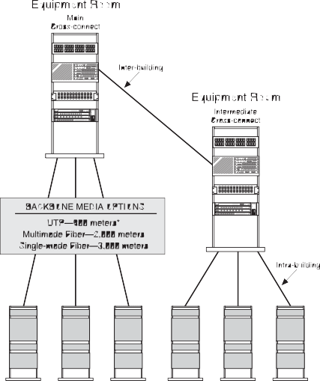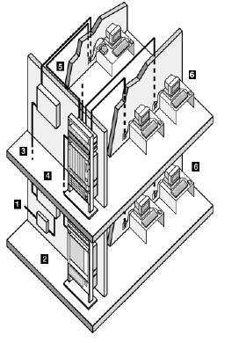

P r odu c t s . Te c hno l ogy . Se r v i c e s . De l i v e r e d Gl ob a l l y.

Fo r mo r e i n f o rma t i on , v i s i t [www.](http://www/) a n i x t e r . c om o r c a l l 1 . 800 . An i x t e r .

StandardsReferenceGuide |9

##### OtherDesignRequirements

• Startopology

• Nomorethantwohierarchical levels ofbackbonecross-connects

* + Bridgetapsarenotallowed

• Mainandintermediatecross-connectjumper orpatchcordlengthsshouldnotexceed20m(66ft)

* + Avoidinstallinginareaswheresourcesofhighlevels ofEMI/RFImayexist

• GroundingshouldmeettherequirementsasdefinedinJ-STD-607-A

**Note:**Itisrecommendedthattheuserconsultwithequipmentmanufacturers, applicationstandardsandsystemprovidersforadditional informationwhen planningshared-sheathapplicationsonUTPbackbonecables.

**MaximumBackboneDistances**

**Mainto Mainto Intermediate**

**Media Horizontal Intermediate toHorizontal**

**Type Cross-Connect Cross-Connect Cross-Connect**

Copper (Voice*) 800m(2,624ft) 500m(1,640ft) 300m(984ft) Multimode 2,000m(6,560ft) 1,700m(5,575ft) 300m(984ft) Single-mode 3,000m(9,840ft) 2,700m(8,855ft) 300m(984ft)

**\*Note:**Backbonedistancesareapplication-dependent.Themaximum distancesspecifiedabovearebasedonvoicetransmissionforUTP anddatatransmissionoverfiber.A90mdistanceappliestoUTP atspectralbandwidthsof5-16MHzforCat3and20-100MHz forCat5e.Currentstate-of-the-artdistributionfacilitiesusuallyinclude acombinationofbothcopperandfiberopticcablesinthebackbone.

**4.TelecommunicationsRoom(TR)** Atelecommunicationsroomistheareawithinabuildingthathousesthe telecommunicationscablingsystemequipment.Thisincludesthemechanical terminationsand/orcross-connectsforthehorizontalandbackbonecabling system.PleaserefertoTIA/EIA-569-Bforthedesignspecifications ofthetelecommunicationsroom.

###### 5.HorizontalCabling SpecifiedHorizontalCablingTopology:Star

Thehorizontalcablingsystemextendsfromtheworkarea

telecommunicationsinformationoutlettothetelecommunications roomandconsistsofthefollowing:

* + Horizontalcabling
  + Telecommunicationsoutlet

• Cableterminations

• Cross-connections

* + Patchcords Fourmediatypesarerecognizedasoptionsforhorizontalcabling, eachextendingamaximumdistanceof90m:
  + 4-pair,100ohmUTP/ScTPcable(24AWGsolidconductors)
  + 2-fiber,62.5/125µmor50/125µmopticalcable

P r odu c t s . Te c hno l ogy . Se r v i c e s . De l i v e r e d Gl ob a l l y.

Fo r mo r e i n f o rma t i on , v i s i t [www.](http://www/) a n i x t e r . c om o r c a l l 1 . 800 . An i x t e r .

10| StandardsReferenceGuide

StandardsReferenceGuide |11

##### MaximumDistancesforHorizontalCabling

**Maximumworkareacablelengthisdeterminedbythefollowingtable:**

**Lengthof Maximum Maximumcombinedlength**

**horizontal lengthofwork ofworkareacables,patch**

**cable areacable(24AWG) cordsandequipmentcable**

**m(ft) m(ft) m(ft)**

90(295) 5(16) 10(33)

85(279) 9(30) 14(46)

80(262) 13(44) 18(59)

75(246) 17(57) 22(72)

70(230) 22(72) 27(89)

**Note:Noworkareacablelengthmayexceed22m(72ft).** Foropticalfiber,anycombinationofhorizontal,workareacables, patchcordsandequipmentcordsmaynotexceed100m(328ft).

##### ConsolidationPoint

**Telecommunications**

**Room Horizontal Cabling**

Work area telecommunication outlet/connector or multi-user telecommunications outlet assembly

Inadditiontothe90mofhorizontalcable,atotalof10misallowed forworkareaandtelecommunicationsroompatchandjumpercables.

###### Multi-userTelecommunicationsOutletAssembly(MUTOA)

Horizontal Cross-Connect

Backbone

**Consolidation Point**

Connecting hardware

Work area cables

Optionalpracticesforopenofficeenvironmentsarespecifiedforany

horizontaltelecommunicationscablingrecognizedinTIA/EIA568-B.

Amulti-usertelecommunicationsoutletassembly(MUTOA)facilitates theterminationofmultiplehorizontalcablesinacommonlocationwithin acolumn,wallorpermanentlysecuredfurniturecluster .Workareacables maythenberoutedthroughfurniturepathwaysanddirectlyconnectedtowork areaequipment.EachfurnitureclustershouldhaveoneMUTOAwhichserves amaximumof12workareas.Ceilingandaccessfloormountingisnot allowedbyTIA/EIA-569-B.

cable **Work Area**

AconsolidationpointdiffersfromaMUTOAinthatitrequiresanadditional connectionforeachhorizontalcablerun.Onlyoneconsolidationpoint (aninterconnectionpointinthehorizontalcabling)isallowedatadistance ofatleast15m(49ft)fromthetelecommunicationsroom.Atransition point(transitionfromroundtoflatundercarpetcable)isnotallowed.

Aconsolidationpointisinstalledinunobstructedbuildingcolumns, permanentwalls,ceilingsoraccessfloors(ifaccessible).

12| StandardsReferenceGuide

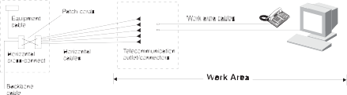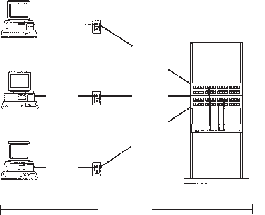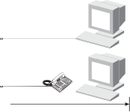

P r odu c t s . Te c hno l ogy . Se r v i c e s . De l i v e r e d Gl ob a l l y.

Fo r mo r e i n f o rma t i on , v i s i t [www.](http://www/) a n i x t e r . c om o r c a l l 1 . 800 . An i x t e r .

StandardsReferenceGuide |13

Themulti-usertelecommunicationsoutletandconsolidationpoint methodsareintendedtobemutuallyexclusive.Labelingandallowance forsparesisrequired.Moves,addsandchangesshouldbeadministered inthetelecommunicationsroom.

##### CentralizedOpticalFiberCabling

TheANSI/TIA/EIA-568-B.1standardoffersmaximumflexibilityfordistributed electronicsformulti-tenantbuildingsbyprovidingforsingle-tenantusers whoprefercentralizedelectronics(i.e.,serverfarms)connectedbyafiber horizontalandfiberbackbone.

**CentralizedCablingScheme**

Toconnectfiberfromtheworkareatotheequipmentroomwithinasingle building,theusermayuseaspliceorinterconnectinthetelecommunications room.Thecombineddistancelimitationis300m(984ft)forhorizontal,intra- buildingbackboneandpatchcords.Alternatively,theusermaysimplypull cablesthroughthecloset.Inthislastcase,thefiberhorizontalandbackbone consistofonecontinuousfiberpair,andthepull-throughdistancelimitationis 90m(295ft).Cablingis62.5/125µmmultimodeor50/125µmmultimode. Sufficientspaceshouldbeallowedforslack,additionandremovalofcables, sparesandconversiontoafullcross-connectsystem.Labelingshould beinaccordancewithTIA/EIA-606-Awithadditional labelingtoidentify

A-Bpairswithspecificworkareas.

**6.WorkArea(WA)** Theworkareacomponentsextendfromthetelecommunications (information)outlettothestationequipment.Workareawiring isdesignedtoberelativelysimpletointerconnectsothatmoves, addsandchangesareeasilymanaged.

###### WorkAreaComponents

• Stationequipment–computers,dataterminals,telephones,etc.

* + Patchcables–modularcords,PCadaptercables, fiberjumpers,etc.
  + Adapters–baluns,etc.(mustbeexternaltotelecommunicationsoutlet)

**TelecommunicationsOutlet** Eachworkareashouldhaveaminimumoftwoinformationoutletports, oneforvoiceandonefordata.

**TelecommunicationsOutlet**

14| StandardsReferenceGuide

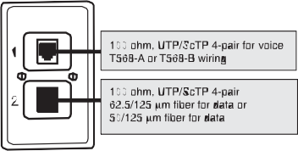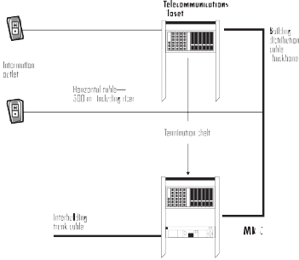

P r odu c t s . Te c hno l ogy . Se r v i c e s . De l i v e r e d Gl ob a l l y.

Fo r mo r e i n f o rma t i on , v i s i t [www.](http://www/) a n i x t e r . c om o r c a l l 1 . 800 . An i x t e r .

StandardsReferenceGuide |15

##### 8-PositionModularJackPairAssignmentsforUTP

**ChannelandPermanentLink** ForthepurposeoftestingUTPcablingsystems,thehorizontalchannel isassumedtocontainatelecommunicationsoutlet/connector,atransition point,90mofUTPcable,across-connectconsistingoftwoblocksorpanels andatotalof10mofpatchcords.Thefigurebelowshowstherelationship ofthesecomponents.

Twolinkconfigurationsaredefinedfortestingpurposes.Thepermanentlink includesthehorizontaldistributioncable,telecommunicationsoutlet/connector ortransitionpointandonehorizontalcross-connectcomponentincluding thematedconnections.Thisisassumedtobethepermanentpartofalink.

Thechannel iscomprisedofthepermanentlinkpluscross-connectequipment, userequipmentcordandcross-connectpatchcable.

**MinimumBendRadius**

HorizontalUTP(4-pair) 4xdiameter HorizontalScTP 8xdiameter BackboneCable 10xdiameter PatchCord Notdetermined

Physicalrequirementsof4-pairUTP: Maximumdiameter:1/4inch Breakingstrength:90lbs.

Maximumpullingtension:25lbs.

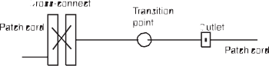

P r odu c t s . Te c hno l ogy . Se r v i c e s . De l i v e r e d Gl ob a l l y.

Fo r mo r e i n f o rma t i on , v i s i t [www.](http://www/) a n i x t e r . c om o r c a l l 1 . 800 . An i x t e r .

16| StandardsReferenceGuide

StandardsReferenceGuide |17

##### DefinitionsofElectricalParameters

**InsertionLoss:**Thistermhasreplacedtheterm“attenuation”(ATTN).

Itisameasureofthedecreaseofsignalstrengthasittravelsdownthemedia.

**NEXT(near-endcrosstalk):**Ameasureoftheunwantedsignalcoupling fromatransmitteratthenear-endintoaneighboring(non-energized) pairmeasuredatthenear-end.

**PSNEXT(powersumnear-endcrosstalk):**Acomputationoftheunwanted signalcouplingfrommultipletransmittersatthenear-endintoaneighboring (non-energized)pairmeasuredatthenear-end.

**FEXT(far-endcrosstalk):**Ameasureoftheunwantedsignalcouplingfrom atransmitteratthenear-endintoaneighboringpairmeasuredatthefar-end.

**ELFEXT(equal-levelfar-endcrosstalk):**Ameasureoftheunwanted signalcouplingfromatransmitteratthenear -endintoaneighboringpair measuredatthefar-end,relativetothereceivedsignal levelmeasured onthatsamepair.ReferredtoasACR-F(insertionlosstocrosstalkratio

far-end)intheTIA/EIA-568-B.2-Addendum10draft.(ELFEXTisFEXTadjusted todiscountinsertionloss.)

**PSAACRF(powersuminsertionlosstoaliencrosstalkratiofar-end):** Acomputationofsignalcouplingfrommultiplepairsofdisturbingchannels, toadisturbedpairinanotherchannelmeasuredatthefar -endandrelative tothereceivedsignal level inthedisturbedpairatthefar-end.Alsoreferred toaspowersumalienequal-levelfar-endcrosstalk(PSAELFEXT).

**PSANEXT(powersumaliennear-endcrosstalk):** Acomputationofsignal couplingfrommultiplenear-enddisturbingchannelpairsintoadisturbedpair ofaneighboringchannelorpartthereof ,measuredatthenear-end.

**PSAFEXT(powersumalienfar-endcrosstalk):** Acomputationofsignal couplingfrommultiplenear-enddisturbingchannelpairsintoadisturbed pairofaneighboringchannelorpartthereof ,measuredatthefar-end.

**ReturnLoss:**Ameasureofthedegreeofimpedancemismatchbetween twoimpedances.Itistheratio,expressedindecibels,oftheamplitude ofareflectedwaveechototheamplitudeofthemainwaveatthejunction ofatransmissionlineandaterminatingimpedance.

**PropagationDelay:**Thetimeneededforthetransmissionofsignal totravelthelengthofasinglepair.

**DelaySkew:**Thedifferencebetweenthepropagationdelayofanytwopairs withinthesamecablesheath.Delayskewiscausedprimarilybecausetwisted pairsaredesignedtohavedifferenttwistsperfoot(laylengths).Delayskew couldcausedatatransmittedoveronechanneltoarriveoutofsyncwith dataoveranotherchannel.

Testsshouldalsomeasurephysical lengthofeachlink,andemploywire maptoverifypinterminationsateachendandidentifysimpleelectrical faults.LevelIIefieldtestequipmentaccuracyisdefined.

Thefollowingtablesshowthelimitationsforboththepermanentlinks andchannel.

|  |
| --- |
| **Category3PermanentLink** |
| **Frequency(MHz) InsertionLoss(dB) NEXT(dB)**  1.0 3.5 40.1  4.0 6.2 30.7  8.0 8.9 25.9 |
| 10.0 9.9 24.3 |
| 16.0 13.0 21.0 |

**Category3PermanentLinkRequirements**

|  |
| --- |
| **Category3Channel** |
| **Frequency(MHz) InsertionLoss(dB) NEXT(dB)**  1.0 4.2 39.1  4.0 7.3 29.3 |
| 8.0 10.2 24.3 |
| 10.0 11.5 22.7  16.0 14.9 19.3 |

**Category3ChannelRequirements**

18| StandardsReferenceGuide

P r odu c t s . Te c hno l ogy . Se r v i c e s . De l i v e r e d Gl ob a l l y.

Fo r mo r e i n f o rma t i on , v i s i t [www.](http://www/) a n i x t e r . c om o r c a l l 1 . 800 . An i x t e r .

StandardsReferenceGuide |19

## TIA/EIA-568-B.2

|  |
| --- |
| **Category5ePermanentLink** |
| **Frequency Insertion NEXT PSNEXT ELFEXT PSELFEXT Return (MHz) Loss(dB) (dB) (dB) (dB) (dB) Loss(dB)**  1.0 2.1 >60 >57 58.6 55.6 19.0  4.0 3.9 54.8 51.8 46.6 43.6 19.0  8.0 5.5 50.0 47.0 40.6 37.5 19.0 |
| 10.0 6.2 48.5 45.5 38.6 35.6 19.0  16.0 7.9 45.2 42.2 34.5 31.5 19.0  20.0 8.9 43.7 40.7 32.6 29.6 19.0  25.0 10.0 42.1 39.1 30.7 27.7 18.0 |
| 31.25 11.2 40.5 37.5 28.7 25.7 17.1 |
| 62.5 16.2 35.7 32.7 22.7 19.7 14.1 |
| 100.0 21.0 32.3 29.3 18.6 15.6 12.0 |

**BalancedTwistedPairCablingComponents**

100ohmUnshieldedTwistedPair(UTP)

**Category5ePermanentLinkRequirements** Maximumlinkpropagationdelay:518nsat10MHz Maximumlinkdelayskew:45nsat100MHz

**HorizontalCable** Astransmissionrateshaveincreased,higherperformanceUTP cablinghasbecomeanecessity.Inaddition,somemeansofclassifying horizontalUTPcablesandconnectinghardwarebyperformancecapability hadtobeestablished.Thesecapabilitieshavebeenbrokendown toaseriesofcategories.Thefollowingcategoriesarecurrentlyrecognized:

**Category3** Cables/connectinghardwarewithtransmissionparameters characterizedupto16MHz

**Category5e** Cables/connectinghardwarewithtransmissionparameters characterizedupto100MHz

**Category3HorizontalandBackboneCable(100meters)**

|  |
| --- |
| **Category5eChannel** |
| **Frequency Insertion NEXT PSNEXT ELFEXT PSELFEXT Return (MHz) Loss(dB) (dB) (dB) (dB) (dB) Loss(dB)**  1.0 2.2 >60 >57 57.4 54.4 17.0  4.0 4.5 53.5 50.5 45.4 42.4 17.0 |
| 8.0 6.3 48.6 45.6 39.3 36.3 17.0 |
| 10.0 7.1 47.0 44.0 37.4 34.4 17.0  16.0 9.1 43.6 40.6 33.3 30.3 17.0  20.0 10.2 42.0 39.0 31.4 28.4 17.0  25.0 11.4 40.3 37.3 29.4 26.4 16.0  31.25 12.9 38.7 35.7 27.5 24.5 15.1  62.5 18.6 33.6 30.6 21.5 18.5 12.1  100.0 24.0 30.1 27.1 17.4 14.4 10.0 |

**Category5eChannelRequirements** Maximumchannelpropagationdelay:555nsat10MHz Maximumchanneldelayskew:50nsat100MHz

**(MHz) Loss(dB) (dB) (dB)**

0.772 2.2 43.0 43

|  |  |  |  |
| --- | --- | --- | --- |
| **Frequency** | **Insertion** | **NEXT** | **PSNEXT** |
|  |  |  |  |

1.0 2.6 40.3 41

4.0 5.6 32.3 32

8.0 8.5 27.8 28

10.0 9.7 26.3 26

16.0 13.1 23.2 23

**Category3HorizontalandBackboneCable** MaximumCat3cablepropagationdelay:545ns/100mat10MHz MaximumCat3cabledelayskew:45ns/100mat16MHz

20| StandardsReferenceGuide

P r odu c t s . Te c hno l ogy . Se r v i c e s . De l i v e r e d Gl ob a l l y.

Fo r mo r e i n f o rma t i on , v i s i t [www.](http://www/) a n i x t e r . c om o r c a l l 1 . 800 . An i x t e r .

StandardsReferenceGuide |21

|  |  |  |  |  |  |  |
| --- | --- | --- | --- | --- | --- | --- |
| **Category5eHorizontalandBackboneCable(100m)** | | | | | | |
| **Frequency** | **Insertion** | **NEXT\*** | **PSNEXT** | **ELFEXT\*** | **PSELFEXT** | **Return** |
| **(MHz)** | **Loss(dB)** | **(dB)** | **(dB)** | **(dB)** | **(dB)** | **Loss(dB)** |
| 0.772 | 1.8 | 67.0 | 64.0 |  |  | 19.4 |
| 1.0 | 2.0 | 65.3 | 62.3 | 63.8 | 60.8 | 20.0 |
| 4.0 4.1 56.3 53.3 51.8 48.8 23.0 | | | | | | |
| 8.0 5.8 51.8 48.8 45.7 42.7 24.5 | | | | | | |
| 10.0 | 6.5 | 50.3 | 47.3 | 43.8 | 40.8 | 25.0 |
| 16.0 | 8.2 | 47.2 | 44.2 | 39.7 | 36.7 | 25.0 |
| 20.0 9.3 45.8 42.8 37.8 34.8 25.0 | | | | | | |
| 25.0 10.4 44.3 41.3 35.8 32.8 24.3 | | | | | | |
| 31.25 11.7 42.9 39.9 33.9 30.9 23.6 | | | | | | |
| 62.5 17.0 38.4 35.4 27.9 24.9 21.5 | | | | | | |
| 100.0 22.0 35.3 32.3 23.8 20.8 20.1 | | | | | | |

**Category5eHorizontalandBackboneCable**

MaximumCat5ecablepropagationdelay:538ns/100mat100MHzMaximum Cat5ecabledelayskew:45ns/100mat100MHz

Characteristicimpedanceofhorizontalcabling=100ohms ± 15 percentfrom1MHztothehighestreferencedfrequency(16or100MHz) ofaparticularcategory.

*Requirementsfor25-paircableareidenticaltothosefor4-paircable.

**BundledandHybridCable** Bundled,wrappedorhybridcablesareallowedforuseinhorizontalcabling, providedthateachindividualcabletypemeetsTIA/EIA-568-B.2specifications andthatpowersumNEXTlosscreatedbyadjacentjacketedcablesbe3dB betterthanthenormallyallowedpair-to-pairNEXTforthecabletypebeing tested.Colorcodesmustfollowindividualcablestandardstodistinguish themfrommultipairUTPbackbonecabling.

**UTPConnectingHardware**

Toensurethatinstalledconnectinghardware(telecommunicationsoutlets, patchcordsandpanels,connectors,cross-connectblocks,etc.)willhave minimaleffectonoverallcablingsystemperformance,thecharacteristics andperformanceparameterspresentedinthissectionmustbemet.

|  |
| --- |
| **Category3ConnectingHardware** |
| **Frequency(MHz) InsertionLoss(dB) NEXT(dB)**  1.0 0.1 58.0  4.0 0.2 46.0 |
| 8.0 0.3 39.9  10.0 0.3 38.0  16.0 0.4 33.9 |

**Category3ConnectingHardware**

22| StandardsReferenceGuide

P r odu c t s . Te c hno l ogy . Se r v i c e s . De l i v e r e d Gl ob a l l y.

Fo r mo r e i n f o rma t i on , v i s i t [www.](http://www/) a n i x t e r . c om o r c a l l 1 . 800 . An i x t e r .

StandardsReferenceGuide |23

|  |  |  |  |  |
| --- | --- | --- | --- | --- |
| **Category5eConnectingHardware** | | | | |
| **Frequency** | **Insertion** | **NEXT** | **FEXT** | **Return** |
| **(MHz)** | **Loss(dB)** | **(dB)** | **(dB)** | **Loss(dB)** |
| 1.0 | 0.1 | 65.0 | 65.0 | 30.0 |
| 4.0 | 0.1 | 65.0 | 63.1 | 30.0 |
| 8.0 | 0.1 | 64.9 | 57.0 | 30.0 |
| 10.0 | 0.1 | 63.0 | 55.1 | 30.0 |
| 20.0 | 0.2 | 57.0 | 49.1 | 30.0 |
| 25.0 | 0.2 | 55.0 | 47.1 | 30.0 |
| 31.25 | 0.2 | 53.1 | 45.2 | 30.0 |
| 62.5 | 0.3 | 47.1 | 39.2 | 24.1 |
| 100.0 | 0.4 | 43.0 | 35.1 | 20.0 |

**Category5eConnectingHardware** ThepreferredterminationmethodforallUTPconnectinghardwareincludes theinsulationdisplacementcontact(IDC).Toensureoverallsystemintegrity, horizontalcablesneedtobeterminatedwithconnectinghardwareofthesame categoryorhigher.

Thefollowingrequirementsapplyonlytowireandcableusedforpatch cordsandcross-connectjumpers:

##### UTPPatchCords

###### Jumper/PatchCordMaximumLengthLimitations:

* + 20m(66ft)inmaincross-connect
  + 20m(66ft)inintermediatecross-connect
  + 6m(20ft)intelecommunicationsroom
  + 3m(10ft)intheworkarea

###### PatchCordCableConstruction:

• Strandedconductorsforextendedflex-lifecablesusedforpatchcords andcross-connectjumpersneedtobeofthesameperformancecategory (orhigher)asthehorizontalcablestheyconnect.

• UTPcablingsystemsarenotCategory3-or5e-compliantunlessall componentsofthesystemsatisfytheirrespectivecategoryrequirements.

**Category5eAssembledPatchCords**

**Frequency 2mCord 5mCord 10mCord Return (MHz) NEXT(dB) NEXT(dB) NEXT(dB) Loss(dB)**

1.0 65.0 65.0 65.0 19.8

4.0 62.3 61.5 60.4 21.6

8.0 56.4 55.6 54.7 22.5

10.0 54.5 53.7 52.8 22.8

16.0 50.4 49.8 48.9 23.4

20.0 48.6 47.9 47.1 23.7

25.0 46.7 46.0 45.3 24.0

31.25 44.8 44.2 43.6 23.0

62.5 39.0 38.5 38.1 20.0

100.0 35.1 34.8 34.6 18.0

**Category5eAssembledPatchCords** InsertionLoss(Attenuation):per100m(328feet)at20˚C= horizontal UTPcableinsertionloss+ 20percent(duetostrandedconductors)

24| StandardsReferenceGuide

P r odu c t s . Te c hno l ogy . Se r v i c e s . De l i v e r e d Gl ob a l l y.

Fo r mo r e i n f o rma t i on , v i s i t [www.](http://www/) a n i x t e r . c om o r c a l l 1 . 800 . An i x t e r .

StandardsReferenceGuide |25

## TIA/EIA-568-B.2-1

|  |
| --- |
| **Category6SolidHorizontalandBackboneCable** |
| **Frequency Insertion NEXT* PSNEXT ELFEXT* PSELFEXT Return (MHz) Loss(dB) (dB) (dB) (dB) (dB) Loss(dB)**  0.772 1.8 76.0 74.0 70.0 67.0 19.4  1.0 2.0 74.3 72.3 67.8 64.8 20.0  4.0 3.8 65.3 63.3 55.8 52.8 23.0 |
| 8.0 5.3 60.8 58.8 49.7 46.7 24.5  10.0 6.0 59.3 57.3 47.8 44.8 25.0  16.0 7.6 56.2 54.2 43.7 40.7 25.0  20.0 8.5 54.8 52.8 41.8 38.8 25.0  25.0 9.5 53.3 51.3 39.8 36.8 24.3 |
| 31.25 10.7 51.9 49.9 37.9 34.9 23.6 |
| 62.5 15.4 47.4 45.4 31.9 28.9 21.5 |
| 100.0 19.8 44.3 42.3 27.8 24.8 20.1  200.0 29.0 39.8 37.8 21.8 18.8 18.0  250.0 32.8 38.3 36.3 19.8 16.8 17.3 |

**BalancedTwistedPairCablingComponents**

**Category6TransmissionPerformance** ThisaddendumdescribesCategory6cables,patchcords,connecting hardware,permanentlinkandchanneltransmissionparameters characterizedupto250MHz.

|  |  |  |  |  |
| --- | --- | --- | --- | --- |
| **MatrixofBackwardCompatibleMatedComponentPerformance** | | | |  |
|  | **Cat3** | **Cat5** | **Cat5e** | **Cat6** |
| Cat3 | Cat3 | Cat3 | Cat3 | Cat3 |
| Cat5 | Cat3 | Cat5 | Cat5 | Cat5 |
| Cat5e | Cat3 | Cat5 | Cat5e | Cat5e |
| Cat6 | Cat3 | Cat5 | Cat5e | Cat6 |

**MatrixofBackwardCompatibleMatedComponentPerformance**

Thelowestratedcomponentdeterminestheratingofthelinkorchannel.

**Category6SolidHorizontalandBackboneCable(100m)\***

MaximumCat6cablepropagationdelay:538ns/100mat100MHz (536at250MHz)

MaximumCat6cabledelayskew:45ns/100matallfrequencies ThePSNEXTperformanceofbundledorhybridcablesmustbe1.2dB greaterthanshownabove.

*Horizontalandbackbonecablesaredefinedonlyasidentical4-paircables.

26| StandardsReferenceGuide

P r odu c t s . Te c hno l ogy . Se r v i c e s . De l i v e r e d Gl ob a l l y.

Fo r mo r e i n f o rma t i on , v i s i t [www.](http://www/) a n i x t e r . c om o r c a l l 1 . 800 . An i x t e r .

StandardsReferenceGuide |27

|  |
| --- |
| **Category6ConnectingHardware** |
| **Frequency Insertion NEXT FEXT Return (MHz) Loss(dB) (dB) (dB) Loss(dB)**  1.0 0.10 75.0 75.0 30.0  4.0 0.10 75.0 71.1 30.0  8.0 0.10 75.0 65.0 30.0  10.0 0.10 74.0 63.1 30.0  16.0 0.10 69.9 59.0 30.0  20.0 0.10 68.0 57.1 30.0  25.0 0.10 66.0 55.1 30.0  31.25 0.11 64.1 53.2 30.0 |
| 62.5 0.16 58.1 47.2 28.1 |
| 100.0 0.20 54.0 43.1 24.0 |
| 200.0 0.28 48.0 37.1 18.0 |
| 250.0 0.32 46.0 35.1 16.0 |

**Category6ConnectingHardware**

|  |
| --- |
| **Category6AssembledPatchCords** |
| **Frequency 2mCord 5mCord 10mCord Return (MHz) NEXT(dB) NEXT(dB) NEXT(dB) Loss(dB)**  .772 65.0 65.0 65.0 19.4 1.0 65.0 65.0 65.0 19.8  4.0 65.0 65.0 65.0 21.6  8.0 65.0 65.0 64.8 22.5  10.0 65.0 64.5 62.9 22.8  16.0 62.0 60.5 59.0 23.4  20.0 60.1 59.6 57.2 23.7  25.0 58.1 56.8 55.4 24.0 |
| 31.25 56.2 54-9 53.6 23.0 |
| 62.5 50.4 49.2 48.1 20.0 |
| 100.0 46.4 45.3 44.4 18.0 |
| 125.0 44.5 43.5 42.7 17.0 |
| 150.0 43.0 42.1 41.4 16.2 |
| 175.0 41.8 40.9 40.2 15.6  200.0 40.6 39.8 39.3 15.0  225.0 39.7 38.9 38.4 14.5  250.0 38.8 38.1 37.6 14.0 |

**Category6AssembledPatchCords** Insertionloss(attenuation)per100m(328ftat20 °C)isdefined asequaltoUTPsolidcableinsertionlossplus20percent. (Theincreasedinsertionlossallowanceisduetostrandedconductors.)

28| StandardsReferenceGuide

P r odu c t s . Te c hno l ogy . Se r v i c e s . De l i v e r e d Gl ob a l l y.

Fo r mo r e i n f o rma t i on , v i s i t [www.](http://www/) a n i x t e r . c om o r c a l l 1 . 800 . An i x t e r .

StandardsReferenceGuide |29

**Category6PermanentLink**

**Frequency Insertion NEXT* PSNEXT ELFEXT* PSELFEXT Return (MHz) Loss(dB) (dB) (dB) (dB) (dB) Loss(dB)**

1.0 1.9 65.0 62.0 64.2 61.2 19.1

4.0 3.5 64.1 61.8 52.1 49.1 21.0

8.0 5.0 59.4 57.0 46.1 43.1 21.0

10.0 5.5 57.8 55.5 44.2 41.2 21.0

16.0 7.0 54.6 52.2 40.1 37.1 20.0

20.0 7.9 53.1 50.7 38.2 35.2 19.5

25.0 8.9 51.5 49.1 36.2 33.2 19.0

31.25 10.0 50.0 47.5 34.3 31.3 18.5

62.5 14.4 45.1 42.7 28.3 25.3 16.0

100.0 18.6 41.8 39.3 24.2 21.2 14.0

200.0 27.4 36.9 34.3 18.2 15.2 11.0

250.0 31.1 35.3 32.7 16.2 13.2 10.0

**Category6PermanentLink** MaximumCat6permanentlinkpropagationdelay:lessthan498nsat10MHz MaximumCat6permanentlinkdelayskew:lessthan44ns/100mat10MHz

|  |
| --- |
| **Category6Channel** |
| **Frequency Insertion NEXT* PSNEXT ELFEXT* PSELFEXT Return (MHz) Loss(dB) (dB) (dB) (dB) (dB) Loss(dB)**  1.0 2.1 65.0 62.0 63.3 60.3 19.0  4.0 4.0 63.0 60.5 51.2 48.2 19.0  8.0 5.7 58.2 55.6 45.2 42.2 19.0  10.0 6.3 56.6 54.0 43.3 40.3 19.0  16.0 8.0 53.2 50.6 39.2 36.2 18.0  20.0 9.0 51.6 49.0 37.2 34.2 17.5  25.0 10.1 50.0 47.3 35.3 32.3 17.0  31.25 11.4 48.4 45.7 33.4 30.4 16.5  62.5 16.5 43.4 40.6 27.3 24.3 14.0  100.0 21.3 39.9 37.1 23.3 20.3 12.0 |
| 200.0 31.5 34.8 31.9 17.2 14.2 9.0  250.0 35.9 33.1 30.2 15.3 12.3 8.0 |

**Category6Channel** MaximumCat6channelpropagationdelay:lessthan555nsat10MHz MaximumCat6channeldelayskew:lessthan50ns/100mat10MHz

**Category6LongitudinalConversionLoss(LCL)**

**Frequency Cable Connector**

**(MHz) LCL(dB) LCL(dB)**

1.0 40.0 40.0

4.0 40.0 40.0

8.0 40.0 40.0

10.0 40.0 40.0

16.0 38.0 40.0

20.0 37.0 40.0

25.0 36.0 40.0

31.25 35.1 38.1

62.5 32.0 32.1

100.0 30.0 28.0

200.0 27.0 22.0

250.0 26.0 20.0

**Category6LongitudinalConversionLoss(LCL)**

LongitudinalConversionTransferLoss(LCTL)isnotyetdefined.

|  |
| --- |
| **TIACategory6versusAugmentedCategory6** |
| **TIACategory TIACategory TIAAugmented ISOClassEA 5eUTP 6UTP Category6UTP**  Recognized  byIEEE802.3an No Yes Yes Yes |
| 55Meter  DistanceSupport No Yes Yes Yes |
| 100Meter  DistanceSupport No No Yes Yes ExtrapolatedTest  LimitsforNEXT  andPSNEXT  to500MHz No No No Yes |

**Note:**ThistablecomparescurrentTIACategory6cablingwithnewTIA andISOspecificationsfor10Gigabitcabling.Thistablesummarizesthevarious UTPcablingoptionsandtheirrespective10Gigabitperformanceattributesas definedbythelatestdraftstandards.Category5eisnotrecognizedasaviable cablingmediatosupport10Gigabittransmissionregardlessofitsinstalled cablingdistance.Category6cablingwillonlysupport10Gigabitatamaximum installeddistanceof55meters.

30| StandardsReferenceGuide

P r odu c t s . Te c hno l ogy . Se r v i c e s . De l i v e r e d Gl ob a l l y.

Fo r mo r e i n f o rma t i on , v i s i t [www.](http://www/) a n i x t e r . c om o r c a l l 1 . 800 . An i x t e r .

StandardsReferenceGuide |31

## TIA/EIA-568-B.2-Addendum10

|  |
| --- |
| **AugmentedCategory6ChannelRequirement** |
| **Frequency Insertion NEXT PSNEXT ACR-F PSACR-F ReturnLoss PSANEXT PSAACRF MHz) Loss(dB) (dB) (dB) (dB) (dB) (dB) (dB) (dB)**  1.0 2.2 65.0 62.0 63.3 60.3 19.0 67.0 67.0  4.0 4.1 63.0 60.5 51.2 48.2 19.0 67.0 65.0  8.0 5.7 58.2 55.6 45.2 42.2 19.0 67.0 58.9  10.0 6.4 56.6 54.0 43.3 40.3 19.0 67.0 57.0 |
| 16.0 8.1 53.2 50.6 39.2 36.2 18.0 67.0 52.9 |
| 20.0 9.1 51.6 49.0 37.2 34.2 17.5 67.0 51.0 |
| 25.0 10.2 50.0 47.3 35.3 32.3 17.0 66.0 49.0 |
| 31.25 11.4 48.4 45.7 33.4 30.4 16.5 65.1 47.1  62.50 16.3 43.4 40.6 27.3 24.3 14.0 62.0 41.1  100.0 20.8 39.9 37.1 23.3 20.3 12.0 60.0 37.0  200.0 30.0 34.8 31.9 17.2 14.2 9.0 55.5 31.0 |
| 250.0 33.8 33.1 30.2 15.3 12.3 8.0 54.0 29.0 |
| 300.0 37.3 31.7 28.8 13.7 10.7 7.2 52.8 27.5 |
| 400.0 43.6 28.7 25.8 11.2 8.2 6.0 51.0 25.0  500.0 49.3 26.1 23.2 9.3 6.3 6.0 49.5 23.0 |

**BalancedTwistedPairCablingComponents (AugmentedCategory6)**

**AugmentedCategory6TransmissionPerformance** ThisaddendumdescribesAugmentedCategory6cables,patchcords, connectinghardware,permanentlinkandchanneltransmissionparameters characterizedupto500MHz.(Pleasenote:thisaddendumisindraft formatthetimeofthispublication.Thisinformationdoesnotreflect thefinalpublishedstandard).

**AugmentedCategory6ChannelRequirement**

|  |
| --- |
| **AugmentedCategory6PermanentLinkRequirements** |
| **Frequency Insertion NEXT PSNEXT ACR-F PSACR-F ReturnLoss PSANEXT PSAACRF MHz) Loss(dB) (dB) (dB) (dB) (dB) (dB) (dB) (dB)**  1.0 1.9 65.0 62.0 64.2 61.2 19.1 67.0 67.0 |
| 4.0 3.5 64.1 61.8 52.1 49.1 21.0 67.0 65.7 |
| 8.0 4.9 59.4 57.0 46.1 43.1 21.0 67.0 59.6  10.0 5.5 57.8 55.5 44.2 41.2 21.0 67.0 57.7  16.0 6.9 54.6 52.2 40.1 37.1 20.0 67.0 53.6 |
| 20.0 7.7 53.1 50.7 38.2 35.2 19.5 67.0 51.7  25.0 8.7 51.5 49.1 36.2 33.2 19.0 67.0 49.7 |
| 31.25 9.7 50.0 47.5 34.3 31.3 18.5 66.2 47.8  62.50 13.9 45.1 42.7 28.3 25.3 16.0 63.1 41.8  100.0 17.9 41.8 39.3 24.2 21.2 14.0 61.1 37.8  200.0 26.0 36.9 34.3 18.2 15.2 11.0 56.6 31.8  250.0 29.4 35.3 32.7 16.2 13.2 10.0 55.5 29.8 |
| 300.0 32.6 34.0 31.4 14.6 11.6 9.2 53.9 28.2  400.0 38.4 29.9 27.1 12.1 9.1 8.0 52.1 25.7  500.0 43.8 26.7 23.8 10.2 7.2 8.0 50.6 23.7 |

**Note:**ThedraftrequirementsforISO(TheInternationalOrganizationfor Standardization)11801ClassEAaremoredemandingcomparedtoTIA/EIA AugmentedCat6draftrequirements.Anixter’sEnterpriseCablingLabtests tothemorestringentISO11801draftstandards.

**AugmentedCategory6PermanentLinkRequirements**

|  |
| --- |
| **ISOComparedtoTIA** |
| **Characteristics500MHz(dB) ISOClassEA TIAAugmentedCat6Draft**  PSNEXTLoss 24.8dB 23.2dB  NEXTLoss 27.9dB 26.1dB |
| PSANEXTLoss 49.5dB 49.5dB |
| ReturnLoss 8.0dB 6.0dB |
| InsertionLoss 49.3dB 49.3dB ReferredtobyIEEE Yes No |

**Note:**SeetheIEEE802.3anandISOClassEAsectionofthisbook formoreinformationon10Gigabitcablingandprotocolmethods.

32| StandardsReferenceGuide

P r odu c t s . Te c hno l ogy . Se r v i c e s . De l i v e r e d Gl ob a l l y.

Fo r mo r e i n f o rma t i on , v i s i t [www.](http://www/) a n i x t e r . c om o r c a l l 1 . 800 . An i x t e r .

StandardsReferenceGuide |33

## TIA/EIA-568-B.3

**OpticalFiberCablingComponents**

|  |
| --- |
| **OpticalFiberCablingSystems** |
| **OpticalFiberCablingMedia**   * Horizontal –62.5/125or50/125µmmultimodeoptical fiber(minimumof twofibers) * Backbone–62.5/125or50/125µmmultimodeorsingle-modeoptical fiber   **CableTransmissionPerformanceParametersMultimode(HorizontalandBackbone)**  **50 µm 62.5 µm**  **Maximum Minimum Minimum Wavelength Attenuation Bandwidth Bandwidth (nm) (dB/km) (MHz/km) (MHz/km)**  850 3.5 500 160  1,300 1.5 500 500 |
| **CableTransmissionPerformanceParametersSingle-mode(Backbone)**  **InsidePlant OutsidePlant Wavelength MaximumAttenuation MaximumAttenuation (nm) (dB/km) (dB/km)**  1,310 1.0 0.5  1,550 1.0 0.5 |

|  |
| --- |
| **OpticalFiberBendRadius** |
| **FiberType BendRadius**  Small InsidePlantCable(2–4fibers) 1" (noload)  2"(withload) |
| AllOther InsidePlantCable 10xdiameter (noload)  15xdiameter (withload) OutsidePlantCable 10xdiameter (noload)  20xdiameter(withload) |

Outsideplantcablemustbewater-blockedandhaveaminimum pullstrengthof600lbs.(Dropcablepullstrengthmaybe300lbs.)

##### OpticalFiberConnector

###### Nospecifiedconnector:568SCandother duplexdesignsmaybeused.

**Color Identification**

* + Beige–multimodeconnector/coupling
  + Blue–single-modeconnector/coupling Note:TheISO/IECstandardnowspecifiesthe568SC-type fiberconnectorintheworkarea.

##### OpticalFiberTelecommunicationsOutlet

###### RequiredFeatures

• Capabilitytoterminateminimumoftwofibersinto568SC couplingsorotherduplexconnection

• Meansofsecuringfiberandmaintainingminimum bendradiusof25mm(1")

##### OpticalFiberSplices,FusionorMechanical

• Maximuminsertionloss0.3dB

• Minimumreturnloss:

–Multimode:20dB

–Single-mode:26dB

–Single-mode:55dB(analogCATV)

##### OpticalFiberConnector(matedpair)

• Maximuminsertionloss0.75dB

##### PatchCords

• Shallbedualfiberofthesametype asthehorizontalandbackbonefiber

* + Polarityshallbekeyedduplex

P r odu c t s . Te c hno l ogy . Se r v i c e s . De l i v e r e d Gl ob a l l y.

Fo r mo r e i n f o rma t i on , v i s i t [www.](http://www/) a n i x t e r . c om o r c a l l 1 . 800 . An i x t e r .

34| StandardsReferenceGuide

StandardsReferenceGuide |35

## Purposeof theANSI/TIA/EIA-569-BStandard

Asthecomplexityofvoiceanddatatelecommunicationshasincreased, standardshavebeenestablishedtoensuretheoperability,flexibility, manageabilityandlongevityofthesecriticalcommercialsupportsystems. Telecommunicationsnowencompassesvoice,dataandvideotransmission ofbusinessinformation,fireandsecurity,audio,environmentalandother intelligentbuildingcontrolsovermediathatincludesfiberoptics,specialized copperdatacabling,microwaveandradiowave.Thisbookletconcisely describesthearchitecturaldesignelementsofcablingpathways anddedicatedroomsfortelecommunicationsequipment.

Amulti-tenantcommercialbuildinghasalifeexpectancyofatleast50 years.Software,hardwareandcommunicationsgearhavefarshorter lifespansofonetofiveyears.Moreover,inamulti-tenantenvironment, continuousmoves,addsandchangesareinevitable.Itisthepurpose ofstandardstoguidedesignandeasefuturechangesbyplanning forthefuturenow.Thesestandardsareintendedtoprovideforageneric structuredcablingplant,capableofrunninganyvoiceordataapplication foreseeableinthenext10to15years.

###### Abbreviations:

AWG AmericanWireGauge V Volts

A Amps

kVA Kilovoltampere

V/m Voltspermeter

SectionContents

**ANSI/TIA/EIA-569-B**

CommercialBuildingStandardfor TelecommunicationsPathwaysandSpaces

DesignConsiderations 39

EntranceFacilities 39

ServiceEntrancePathways 39

EquipmentRoom................................................... 40

IntrabuildingBackbonePathways 42

TelecommunicationsRoom 43

HorizontalPathways 44

UnderfloorDuct 44

Flushduct .................................................... 44

Multi-channelRaceway 44

CellularFloor 44

Trenchduct 44

AccessFloor 44

Plenum/Ceiling 44

Conduit...................................................... 45

CableTrays................................................... 45

PerimeterPathways 45

ConsolidationPointsandMUTOAs 47

ElectromagneticInterference 47

Firestops.......................................................... 48

|

P r odu c t s . Te c hno l ogy . Se r v i c e s . De l i v e r e d Gl ob a l l y.

StandardsReferenceGuide |37

## PathwaysandSpaces

1.ElectricEntrance 5.Voice 2.TelcoEntrance 6.TelecommunicationsRoom 3.TelecommunicationsEquipmentRoom 7.GroundingandBonding

4.Data 8.UnderfloorSystem

**TIA/EIA-569-BDesignConsiderations EntranceFacilities** Entrancefacilitiesincludethepathwaysforoutsidecarrierservices, interbuildingbackbone,alternateentranceandantennaeentrancepathways. Theentrancefacilitiesconsistofaterminationfieldinterfacinganyoutside cablingtotheintrabuildingbackbonecabling.Thelocaltelephonecarrier istypicallyrequiredtoterminatecablingwithin50ftofbuildingpenetration andtoprovideprimaryvoltageprotection.

Inbuildingslargerthan20,000usablesq.ft.,alocked,dedicated,enclosed roomisrecommended.Beyond70,000sq.ft.,alocked,dedicatedroom isrequired,withaplywoodterminationfieldprovidedontwowalls.

Inbuildingsupto100,000usablesq.ft.,awall-mountedterminationfield mayserveastheentrancefacility,using3/4-inchplywood,8fthigh.Beyond 100,000sq.ft.,rack-mountedandfree-standingframesmayalsoberequired. Minimumspacerequirementsaregivenasfollows:

**ServiceEntrancePathways** Forundergroundfacilities,useaminimum4-inchconduitorduct constructedofPVCtypeB,CorD,multipleplasticduct,galvanizedsteel,or fiberglasswithappropriateencasement.Nomorethantwo90°manufactured bendsareallowed(10timesthediameter).Drainslopeshouldnotbeless than12inchesper100ft.Recommendedconduitfillvariesbutshould notexceed40percentformorethantwocables.

Maintenanceholes(typically3,500lb./sq.in.,concrete)mustbeequipped withsump,corrosion-protectedpullingiron,cableracks,groundedladder andonlysuchpowerandlightconductorsasrequiredfortelecommunications supportperNECrequirements.

38| StandardsReferenceGuide

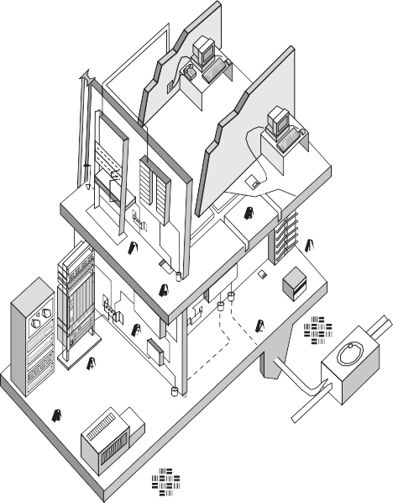

P r odu c t s . Te c hno l ogy . Se r v i c e s . De l i v e r e d Gl ob a l l y.

Fo r mo r e i n f o rma t i on , v i s i t [www.](http://www/) a n i x t e r . c om o r c a l l 1 . 800 . An i x t e r .

StandardsReferenceGuide |39

|  |
| --- |
| **GrossBuilding FloorSpace**  **(sq. ft./sq.m.) PlywoodField RoomDimension**  5,000/465 8'highx39"wide (3mx99cm) |
| 10,000/1,000 8'highx39" (3mx99cm) 20,000/2,000 8'highx42" (3mx107cm) (Aroomrecommended 40,000/4,000 8'highx68" (3mx173cm) beyondthislevel) |
| 50,000/5,000 8'highx90" (3mx229cm) |
| 60,000/6,000 8'highx96" (3mx244cm) (Adedicatedroomrequired) 80,000/8,000 8'highx120" (3mx305cm) 12'x6.3' (4mx2m) 100,000/10,000 8'highx2walls (3mx2walls) 12'x6.3' (4mx2m) 200,000/20,000 8'highx2walls (3mx2walls) 12'x9' (4mx3m) 400,000/40,000 8'highx2walls (3mx2walls) 12'x13' (4mx4m) 500,000/50,000 8'highx2walls (3mx2walls) 12'x15.6' (4mx5m) 600,000/60,000 8'highx2walls (3mx2walls) 12'x18.3' (4mx6m) 800,000/80,000 8'highx2walls (3mx2walls) 12'x22.3' (4mx7m) |
| 1,000,000/100,000 8'highx2walls (3mx2walls) 12'x27.7' (4mx9m) |

**Ruleofthumb:**Allow1sq.ft.(929sq.centimeter)ofplywoodwallmount foreach200sq.ft.(19sq.meter)areaoffloorspace.

**EquipmentRoom** Anequipmentroomisessentiallyalargetelecommunicationsroomthatmay housethemaindistributionframe,PBXs,secondaryvoltageprotection,etc.The equipmentroomisoftenappendedtotheentrancefacilitiesoracomputerroom toallowsharedairconditioning,security,firecontrol,lightingandlimitedaccess.

**Numberof EquipmentRoom**

**Workstations FloorSpace(sq. ft.)**

1–100 150 (14sq.meters) 101–400 400 (38sq.meters)

401–800 800 (74sq.meters) 801–1,200 1,200 (111sq.meters)

**Ruleofthumb:**Provide0.75sq.ft.(697sq.centimeter)ofequipmentroom floorspaceforevery100sq.ft.(9sq.meter)ofuserworkstationarea.

**Location** Typically,roomsshouldbelocatedawayfromsourcesofelectromagnetic interference(transformers,motors,x-ray,inductionheaters,arcwelders, radioandradar).

**Perimeters** Typically,nofalseceiling;allsurfacestreatedtoreducedust; wallsandceilingpaintedwhiteorpasteltoimprovevisibility.

###### LimitedAccess

Typically,singleordouble36”x80” lockabledoorswithnodoorsills.

**Other** Typically,nopiping,ductwork,mechanicalequipmentorpowercablingshould beallowedtopassthroughtheequipmentroom.Nounrelatedstorage.

###### CeilingHeight

Minimumclearheightinroomshallbe8ft.(2.4m),theheightbetweenthe finishedfloorandthelowestpointshouldbe10ft.(3m)toaccommodatetall racksandoverheadraceways.Falseceilingsshouldnotbeinstalled.

###### HVAC

24hoursaday,365daysayear,64° to75°F,30to55percenthumidity,positive pressure,withindependentpowerfromtelecommunicationsequipment.

###### Lighting

Typically,8.5ft.high,providing50ft.candlesat3ft.abovefloor.

###### Electrical

Typically,aminimumof twodedicated15A,110VACduplexoutletson separatecircuitsisrequired.Convenienceduplexoutletsshallbeplaced at6ft. intervalsaroundtheperimeter.Emergencypowershouldbe consideredandsuppliedifavailable.

###### BondingandGrounding

AccessshallbeavailabletothebondingandgroundingasspecifiedinJ-STD-607-A.

###### Dust

Lessthan100micrograms/cubicmeter/24hourperiod.

**Note:**Theterm“typically” isappliedheretoindicate,whereapplicable, thattheserequirementsalsoapplytootherelementsofthecablingsystem spaces.Lightingrequirements,forinstance,arelargelyidenticalforentrance facilities,equipmentroomsandtelecommunicationrooms.

40| StandardsReferenceGuide

P r odu c t s . Te c hno l ogy . Se r v i c e s . De l i v e r e d Gl ob a l l y.

Fo r mo r e i n f o rma t i on , v i s i t [www.](http://www/) a n i x t e r . c om o r c a l l 1 . 800 . An i x t e r .

StandardsReferenceGuide |41

**IntrabuildingBackbonePathways** Withinabuilding,theintrabuildingbackbonepathwaysextendbetween theentrancefacilities,equipmentroomandtelecommunicationsrooms. Telecommunicationroomsshouldbestackedverticallyaboveeachotheron eachfloor,andprovidedwithaminimumofthree4-inchsleeves(astubof conduitthroughthefloor)forlessthan50,000sq.ft.served.Anequivalent 4"x12"slotmaybeusedinlieuofthreesleeves.Firestoppingisrequired. Ifroomsarenotverticallyaligned,then4-inchhorizontalconduitrunsare required.Includenomorethantwo90°bendsbetweenpullpoints.Pulling ironoreyesembeddedintheconcreteforcablepullingisrecommended. Fillshouldnotexceed40percentforanyrungreaterthantwocables.

**BackboneandHorizontalPathways**

**TelecommunicationsRoom** Thetelecommunicationsroomoneachflooristhejunctionbetweenbackbone andhorizontalpathways.Itcontainsactivevoiceanddatatelecommunications equipment,terminationfieldsandcross-connectwiring.Morethanone telecommunicationsroomperfloorisrequiredifdistancetoaworkarea exceeds300feet,oriffloorareaservedexceeds10,000squarefeet.

Recommendedroomsizingis10'x11'foreach10,000square-footarea served.Power,lighting,airconditioningandlimitedaccessaretypical. Seerequirementsforequipmentroom.Thereareaminimumofthree4-inch firestoppedbackbonesleevesinthefloorattheleftsideofaplywood terminationfield,whichareideallylocatednearthedoor.Afireextinguisher isrecommended.

**RiserSleeve**

1. TelcoConduit 6.VerticalBackbone
2. TelcoManhole 7.TelecommunicationsRoom
3. EntranceConduit 8.HorizontalCabling
4. TelcoEntranceFacility 9.InterbuildingBackbone 5.TelecommunicationsEquipmentRoom 10.ElectricalEntranceFacility

**TypicalTelecommunicationsRoom**

42| StandardsReferenceGuide

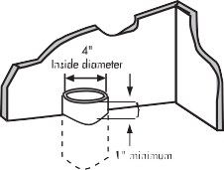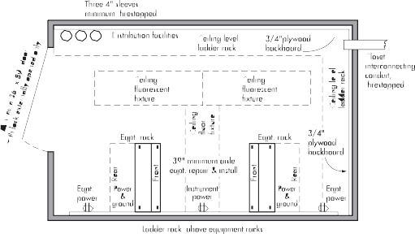

P r odu c t s . Te c hno l ogy . Se r v i c e s . De l i v e r e d Gl ob a l l y.

Fo r mo r e i n f o rma t i on , v i s i t [www.](http://www/) a n i x t e r . c om o r c a l l 1 . 800 . An i x t e r .

StandardsReferenceGuide |43

**HorizontalPathways** Horizontalpathwaysextendbetweenthetelecommunicationsroomandthe workarea.Avarietyofgenericpathwayoptionsaredescribed.Choiceof pathway(s)islefttothediscretionofthedesigner.Themostcommonly employedpathwayconsistsofcablebundlesrunfromthetelecommunications roomalongJ-hookssuspendedaboveaplenumceiling,whichfanoutoncea workzoneisreached.Theythendropthroughinteriorwallsorsupportcolumns orraceways,andterminateataninformationoutlet(I/O).

Otheroptionsincludethefollowing:

###### UnderfloorDuct

Single-ordual-levelrectangularductsimbeddedingreater than2.5-inch(7cm)concreteflooring.

###### Flushduct

Single-levelrectangularductimbeddedflushingreater than1-inch(3cm)concreteflooring.

**Multi-channelRaceway** Cellularracewayductscapableofroutingtelecommunicationsandpower cablingseparatelyingreaterthan3-inch(8cm)reinforcedconcrete.

###### CellularFloor

Pre-formedhollowsorsteel-linedcellsareprovidedinconcretewithheader ductsfromthetelecommunicationsroomarrangedatrightanglestothecells.

**Trenchduct** Awide,solidtray,sometimescontainingcompartments,andfitted withaflattop(withgaskets)alongitsentirelength.Itisembeddedflush withtheconcretefinish.

**AccessFloor** Modularfloorpanelssupportedbypedestals,usedincomputerrooms andequipmentrooms.

**Plenum/Ceiling** Bundledcables,suspendedaboveafalseceiling,fanouttodropthrough walls,powerpolesoralongsupportcolumnstobaseboardlevel.

###### Conduit

Tobeconsideredonlywhenoutletlocationsarepermanent,devicedensity lowandflexibility(futurechanges)arenotrequired.

###### CableTrays

Optionsincludechanneltray,laddertray,solidbottom,ventilatedandwireway.

**PerimeterPathways** Optionsincludesurfaceraceway,recessed,moldingandmultichannel (tocarryseparatepowerandlightingcircuits).

**Ruleofthumb:**Typically,sizehorizontalpathwaysbyproviding1sq.in. ofcross-sectionareaforevery100sq.ft.ofworkspaceareabeingserved.

**PerimeterPathwayandModularOfficePath**

**Note:**Typically,apullbox,spliceboxorpullingpointisrequired foranyconstrainedpathwaywheretherearemorethantwo90°bends, a180° reversebendorlengthmorethan100ft.

P r odu c t s . Te c hno l ogy . Se r v i c e s . De l i v e r e d Gl ob a l l y.

Fo r mo r e i n f o rma t i on , v i s i t [www.](http://www/) a n i x t e r . c om o r c a l l 1 . 800 . An i x t e r .

44| StandardsReferenceGuide

StandardsReferenceGuide |45

## AVarietyofHorizontalPathways

**AccessFloor**

**AccessFloor**

**CeilingUtilityPole**

**ConsolidationPointsandMUTOAs** Consolidationpointsprovidelimitedareaconnectionaccess.Typically, apermanentflushwall,ceilingorsupportcolumn-mountedpanelserves modularfurnitureworkareas.Thepanelsmustbeunobstructedandfully accessiblewithoutmovingfixtures,equipmentorheavyfurniture.

AMulti-UserTelecommunicationOutletAssembly(MUTOA)isanother methodologytoreducecablingmoves,addsandchangesinmodularfurniture settings.TheusercordisdirectlyconnectedtotheMUTOA.AMUTOAlocation mustbeaccessibleandpermanent,andmaynotbemountedinceilingspaces orunderaccessflooring.Similarly,itcannotbemountedinfurnitureunless thatfurnitureispermanentlysecuredtothebuildingstructure.

Formoredescriptiveinformationondistancelimitationsandpurposes ofconsolidationpointsandMUTOAs,seeANSI/TIA/EIA-568-B.1.

**ElectromagneticInterference** Voiceanddatatelecommunicationscablingshouldnotberunadjacent andparalleltopowercabling–evenalongshortdistances–unlessone orbothcabletypesareshieldedandgrounded.Forlowvoltagecommunication cables,aminimum5-inchdistanceisrequiredfromanyfluorescentlighting fixtureorpowerlineover2kVAandupto24inchesfromanypowerlineover 5kVA*.Ingeneral,telecommunicationscablingisroutedseparately,orseveral feetawayfrompowercabling.Similarly,telecommunicationscablingisrouted awayfromlargemotors,generators,inductionheaters,arcwelders,x-ray equipmentandradiofrequency,microwaveorradarsources.

**\*Note:**Distancerecommendationsfrom(1990)TIA/EIA-569arereproduced herebypopularrequest.Forcurrentrecommendations,referto NEC/NFPA70,Article800-52.

46| StandardsReferenceGuide

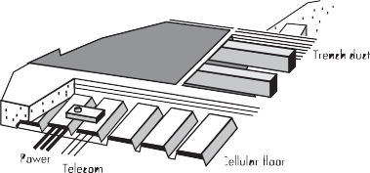

P r odu c t s . Te c hno l ogy . Se r v i c e s . De l i v e r e d Gl ob a l l y.

Fo r mo r e i n f o rma t i on , v i s i t [www.](http://www/) a n i x t e r . c om o r c a l l 1 . 800 . An i x t e r .

StandardsReferenceGuide |47

##### Firestops

AnnexAofthestandarddiscussesvarioustypesofpackingused

tore-establishtheintegrityoffire-ratedstructureswhenthesebarriers havebeenpenetratedbycable.Thissectionofthestandardbrieflydiscusses passivemechanicalsystemsandnon-mechanicalsystemssuchasputty,caulk, cements,intumescentsheetsandstrips,siliconefoamsandpre-manufactured pillows.Themostcommonmethodisstuffingallapertureswith ceramic/mineralwoolandcaulkingbothsideswithfire-resistantputty.

Theinformationrefersthedesignertocheckmanufacturerspecifications andULratingsagainstNFPA,ASTMandNECcodes.

**Cut-a-WayofTypicalFirestop**

## Purposeof theANSI/TIA/EIA-606-AStandard

Modernbuildingsrequireaneffectivetelecommunicationsinfrastructure tosupportthewidevarietyofservicesthatrelyontheelectronictransport ofinformation.Administrationincludesbasicdocumentationandtimely

updatingofdrawings,labelsandrecords.Administrationshouldbesynergistic withvoice,dataandvideotelecommunications,aswellaswithotherbuilding signalsystems,includingsecurity,audio,alarmsandenergymanagement.

Administrationcanbeaccomplishedwithpaperrecords,butintoday’s increasinglycomplextelecommunicationsenvironment,effective administrationisenhancedbytheuseofcomputer-basedsystems. Amulti-tenantcommercialbuildinghasalifeexpectancyofatleast 50years.Moreover,inamulti-tenantenvironment,continuousmoves, addsandchangesareinevitable.

Administrativerecordkeepingplaysanincreasinglynecessaryrole intheflexibilityandmanagementoffrequentmoves,addsandchanges. Thisbookletconciselydescribestheadministrativerecordkeepingelements ofamodernstructuredcablingsystem.

P

r o d u c t s

.

T

e c h n o

l o g y

.

S

e r v i c e s

.

D

e l i v

e r e d

G

l o b a l l y

.

StandardsReferenceGuide |49

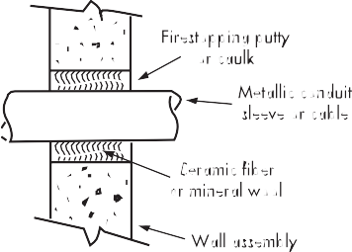

Fo r mo r e i n f o rma t i on , v i s i t [www.](http://www/) a n i x t e r . c om o r c a l l 1 . 800 . An i x t e r .

48| StandardsReferenceGuide

SectionContents

**TIA/EIA-606-A**

AdministrationStandardforCommercial TelecommunicationsInfrastructure

ElementsofanAdministrationSystem 51

ClassesofAdministration 52

Class1Administration 53

Class2Administration 54

Class3Administration 55

Class4Administration 56

IdentificationFormats 57

SummaryofRecordElements 58

Grounding/BondingAdministration 59

LabelColorCoding.................................................. 59

**TIA/EIA-606-A**

AdministrationStandardforCommercialTelecommunicationsInfrastructure

###### ElementsofanAdministrationSystem:

* + Horizontalpathwaysandcabling
  + Backbonepathwaysandcabling
  + Telecommunicationsgrounding/bonding

• Spaces(e.g.entrancefacility,telecommunicationsroom,equipmentroom)

* + Firestopping

Thefigurebelowillustratesatypicalmodelfortheinfrastructureelements usedinanadministrationsystem:

50| StandardsReferenceGuide

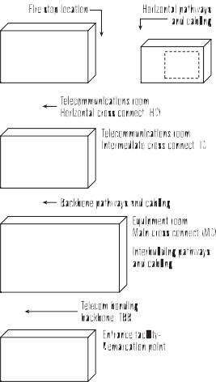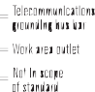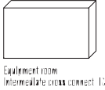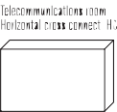

P r odu c t s . Te c hno l ogy . Se r v i c e s . De l i v e r e d Gl ob a l l y.

Fo r mo r e i n f o rma t i on , v i s i t [www.](http://www/) a n i x t e r . c om o r c a l l 1 . 800 . An i x t e r .

StandardsReferenceGuide |51

**ClassesofAdministration** Fourclassesofadministrationarespecifiedinthisstandardtoaccommodate diversedegreesofcomplexitypresentintelecommunicationsinfrastructure. Eachclassdefinestheadministrationrequirementsforidentifiers,records andlabeling.Anadministrationsystemcanbemanagedusingapaper-based system,general-purposespreadsheetsoftware,orspecial-purposecable managementsoftware.

|  |  |  |  |  |
| --- | --- | --- | --- | --- |
| **Identifier** | **Descriptionof Identifier** | **ClassofAdministration**  **1 2 3 4** | | |
| fs | TelecommunicationsSpace(TS) | R | R R | R |
| fs-an | Horizontal link | R | R R | R |
| fs-TGMB | TelecommunicationsMain | R | R R | R |
|  | GroundingBusbar(TMGB) |  |  |  |
| fs-TGB | Telecommunications | R | R R | R |
|  | GroundingBusbar(TGB) |  |  |  |
| fs1/fs2-n | Buildingbackbonecabling |  | R R | R |
| fs1/fs2-n.d | Buildingbackbonepairoroptical fiber |  | R R | R |
| f-FSLn(h) | Firestoplocation |  | R R | R |
| [b1-fs1]/[b2-fs2]-n | Campusbackbonecable |  | R | R |
| [b1-fs1]/[b2-fs2]-n/d | Campusbackboneoroptical fiber |  | R | R |
| b | Building |  | R | R |
| c | Campusorsite |  |  | R |

**Class1Administration** Class1addressestheadministrationrequirementsforabuildingor premisethatisservedbyasingleEquipmentRoom(ER).

ThefollowinginfrastructureidentifiersshallberequiredinClass1 Administrationwhenthecorrespondingelementsarepresent:

* + TelecommunicationsSpace(TS)identifier
  + HorizontalLinkidentifier
  + TelecommunicationsMainGroundingBusbar(TMGB)
  + TelecommunicationsGroundingBusbar(TGB)

|  |
| --- |
| **Class1Identifiers** |
| f = numericcharacter (s) identifyingthefloorof thebuildingoccupiedbytheTS s = alphacharacter(s)uniquelyidentifyingtheTSonfloorf,orthebuildingarea  inwhichthespaceislocated  fs = theTSidentifier |
| a = oneortwoalphacharactersuniquelyidentifyingasinglepatchpanel, agroupofpatchpanelswithsequentiallynumberedports,oranIDCconnector (punchdownblock),oragroupofIDCconnectors,servingaspartof the horizontalcross-connect |
| n = twotofournumericcharactersdesignatingtheportonapatchpanel, orthesectionofanIDCconnectoronwhichafour-pairhorizontalcable  isterminatedintheTS TMGB = portionofanidentifierdesignatingatelecommunicationsmaingroundingbusbar |
| TGB = portionofanidentifierdesignatingatelecommunicationsgroundingbusbar |

52| StandardsReferenceGuide

P r odu c t s . Te c hno l ogy . Se r v i c e s . De l i v e r e d Gl ob a l l y.

Fo r mo r e i n f o rma t i on , v i s i t [www.](http://www/) a n i x t e r . c om o r c a l l 1 . 800 . An i x t e r .

StandardsReferenceGuide |53

**Class2Administration**

Class2addressestheadministrationofinfrastructurewithoneormore TelecommunicationsSpaces(TS)inasinglebuilding.

ThefollowinginfrastructureidentifiersshallberequiredinClass2 Administrationwhenthecorrespondingelementsarepresent:

* + IdentifiersrequiredinClass1Administration
  + Buildingbackbonecableidentifier
  + Buildingbackbonepairoropticalfiberidentifier
  + Firestoppinglocationidentifier Class2Administrationmayadditionallyincludepathwayidentifiers.

|  |
| --- |
| **Class2Identifiers** |
| fs1 = TSidentifierforthespacecontainingtheterminationofoneend  of thebackbonecable  fs2 = TSidentifierforthespacecontainingtheterminationof theotherend of thebackbonecable |
| n = oneortwoalpha-numericcharactersidentifyingasinglecablewith oneendterminatedintheTSdesignatedfs1andtheotherendterminated intheTSdesignatedFS2 |
| fs1/fs2-n = abuildingbackbonecableidentifier |
| d = twotofournumericcharactersidentifyingasinglecopperpairor asingleoptical fiber |
| FSL = anidentifierreferringtoafirestoppinglocation |
| h = onenumericcharacterspecifyingthehourratingofafirestoppingsystem |

**Class3Administration** Class3Administrationaddressesinfrastructurewithmultiplebuildings atasinglesite.

ThefollowinginfrastructureidentifiersshallberequiredinClass3Administration:

* + IdentifiersrequiredinClass2Administration
  + Buildingidentifier

• Campusbackbonecableidentifier

• Campusbackbonepairoropticalfiberidentifier

Thefollowinginfrastructureidentifiersareoptional inClass3Administration:

* + Identifiersoptional inClass2Administration

• Outsideplantpathwayelementidentifier

• Campuspathwayorelementidentifier Additional identifiersmaybeaddedifdesired.

|  |
| --- |
| **Class3Identifiers** |
| [b1-fs1]/[b2-fs2]-n = Campusbackboneidentifier d = twotofournumericcharactersidentifyingasinglecopperpairor  asingleoptical fiber |
| b = oneormorealphanumericcharactersidentif yingasinglebuilding |

54| StandardsReferenceGuide

P r odu c t s . Te c hno l ogy . Se r v i c e s . De l i v e r e d Gl ob a l l y.

Fo r mo r e i n f o rma t i on , v i s i t [www.](http://www/) a n i x t e r . c om o r c a l l 1 . 800 . An i x t e r .

StandardsReferenceGuide |55

**Class4Administration** Class4Administrationaddressesinfrastructurewithmultiplesites orcampuses.

ThefollowinginfrastructureidentifiersshallberequiredinClass4Administration:

* + IdentifiersrequiredinClass3Administration

• Campusorsiteidentifier

Thefollowinginfrastructureidentifiersareoptional inClass4Administration:

* + Identifiersoptional inClass3Administration
  + Inter-campuslementidentifier

Additional identifiersmaybeaddedifdesired.

**Class4Identifiers**

c = oneormorealpha-numericcharactersidentifyingacampusorasite

**IdentificationFormats** Auniquealphanumericidentificationcodeiscreatedforeverylocation, pathway,cableandterminationpoint.Suggestionsinthestandardinclude:

|  |  |
| --- | --- |
| **AlphanumericIdentificationCode** | |
| BCxxx bondingconductor | HHxxx handhole |
| BCDxxx backboneconduit | ICxxx intermediatecross-connect |
| Cxxx cable | Jxxx jack |
| CBxxx backbonecable | MCxxx maincross-connect |
| CDxxx conduit | MHxxx manholeormaintenancehole |
| CTxxx cabletray | PBxxx pullbox |
| ECxxx equipment(bonding)conductor | Sxxx splice |
| EFxxx entrancefacility | SExxx serviceentrance |
| ERxxx equipment room | SLxxx sleeve |
| Fxxx fiber | TCxxx telecommunicationscloset |
| GBxxx groundingbusbar | TGBxxx telecommunicationsgroundingbusbar |
| GCxxx groundingconductor | TMGB telecommunicationsmaingroundingbusbar |
|  | WAxxx workarea |

##### IdentificationFormatExample

Theactualformatintheprecedingchartisnotmandatedbythestandard. However,thechosenformatmustbeconsistentandprovideauniqueidentifier numberforeachsystemelement.Thismethodlendsitselftoorganization andupdatingofmultiplerecordsbytheuseofpowerfulrelationaldatabase (three-dimensionalspreadsheet)programs.

###### IdentificationExample

J0001 Labelforaninformationoutletjack D306 Designationforaworkarea

3A-C17-005 Terminationincloset3A,columnC,row17,blockposition005

Exampleslikethoseabove(takenfromtheTIA/EIA606-Atextand administrativelabelingmap)indicatetheflexibilityofconventionsthat canbeestablishedforpurposesofnaming.Logicalnamingconventions canalsoconveyconsiderableadditional informationaboutotherlinkages. Furtherexamplesareincludedinthecompletestandard.

P r odu c t s . Te c hno l ogy . Se r v i c e s . De l i v e r e d Gl ob a l l y.

Fo r mo r e i n f o rma t i on , v i s i t [www.](http://www/) a n i x t e r . c om o r c a l l 1 . 800 . An i x t e r .

56| StandardsReferenceGuide

StandardsReferenceGuide |57

**SummaryofRecordElements** Thistableoutlinestheminimumrequiredinformationandrequired linkages.Furtherinformationisoptional.Amultidimensionaldatabase orspreadsheetishelpful.

**Grounding/BondingAdministration** Telecommunicationssystemsrequireareliableelectricalgroundreference potential,providedbyadedicatedgrounding/bondingconductornetwork.

**WARNING**

###### IFTHISCLAMPORCABLE ISLOOSEORMUSTBEREMOVED, PLEASECALLTHEBUILDING TELECOMMUNICATIONSMANAGER

Bondingconductorcablingshallbecoloredgreenor labeledappropriately withanalphanumericidentifierandwarninglabel.Groundingrecords aresimilartocablerecordformat.

|  |  |  |  |
| --- | --- | --- | --- |
| **Pathways**  **& Spaces** | **Record**  Pathway | **RequiredInformation** PathwayIdentification# PathwayType PathwayFill  PathwayLoad | **RequiredLinkages** CableRecords SpaceRecords PathwayRecords  GroundingRecords |
| Space | SpaceIdentification# SpaceType | PathwayRecords CableRecords  GroundingRecords |
| **Wiring** | Cable | CableIdentification# CableType UnterminatedPair #s DamagedPair #s  AvailablePair #s | TerminationRecords SpliceRecords PathwayRecords GroundingRecords |
| Termination Hardware | TerminationHardware #s  TerminationHardwareType DamagedPosition#s | TerminationPositionRecords  SpaceRecords GroundingRecords |
| Termination Position | TerminationPosition# TerminationPositionType UserCode  CablePair/Condition#s | CableRecords OtherTerminationRecords TerminationHardwareRecords  SpaceRecords |
| Splice | SpliceIdentification#  SpliceType | CableRecords  SpaceRecords |
| **Grounding** | TMGB | TMGBIdentification# BusbarType GroundingConductor #s ResistancetoEarth  DateofMeasurement | BondingConductorRecords SpaceRecords |
| Bonding  Conductor | BondingConductorID#  ConductorType BusbarIdentification# | GroundingBusbarRecords PathwayRecords |
| TGB | BusbarIdentification# BusbarType | BondingConductorRecords SpaceRecords |

###### Grounding/BondingTerms(withacronyms):

**TMGB** TelecommunicationsMainGroundingBusbar

**TBB** TelecommunicationsBondingBackbone

**TGB** TelecommunicationsGroundingBusbar

**TBBIBC** TelecommunicationsBondingBackbone InterconnectingBondingConductor

##### LabelColorCoding

Shownherearethecolorcodesusedforterminationfieldlabels.

**TerminationType Color Comments**

DemarcationPoint Orange COterminations NetworkConnections Green alsoaux.circuit terms. CommonEquipment Purple PBX,Host,LANs,Mux First-levelBackbone White MC-ICterminations Second-levelBackbone Gray IC-TCterminations Station Blue Horizontalcableterms.

InterbuildingBackbone Brown Campuscableterms. Miscellaneous Yellow Aux., maint., security KeyTelephoneSystems Red

Theabbreviation“term(s).” isusedinthisexample(forspaceconsiderations) tomean“termination(s).”

58| StandardsReferenceGuide

P r odu c t s . Te c hno l ogy . Se r v i c e s . De l i v e r e d Gl ob a l l y.

Fo r mo r e i n f o rma t i on , v i s i t [www.](http://www/) a n i x t e r . c om o r c a l l 1 . 800 . An i x t e r .

StandardsReferenceGuide |59

## ThePurposeofJ-STD-607-A

Thisstandardspecifiesauniformtelecommunicationsgrounding andbondinginfrastructurethatshallbefollowedwithincommercial buildings.FollowingtheAT&Tdivestitureof1984, theenduserbecame responsibleforallpremisescablingforvoiceanddata.Advancements invoicecommunicationsandtheconvergenceofvoiceanddata communicationsledtoincreasinglycomplexinteractivesystems ownedandmaintainedbytheenduser.Thesesystemsrequire areliableelectricalground-referencepotential.Grounding byattachment tothenearestpieceof ironpipeisnolonger satisfactorytoprovideground-referenceforsophisticated activeelectronicssystems.

SectionContents

**J-STD-607-A**

CommercialBuildingGroundingand BondingRequirementsforTelecommunications

DesignConsiderations 62

Terms ............................................................ 62

SchematicDiagram 63

.

r e t

x i n

A

. 0

0

8

. 1

l l a c

r o

m o c

.

r e t

x i n

a

.

w w w

t i s i v

,

n o i t a

m r

o f

n i

e r o m

r o F

60| StandardsReferenceGuide

P r odu c t s . Te c hno l ogy . Se r v i c e s . De l i v e r e d Gl ob a l l y.

StandardsReferenceGuide |61

**DesignConsiderations** Solidcoppergroundingbusbars(1/4" thick x4"highxvariable length)areinstalledwithinsulatedstandoffsinentrancefacilities

andtheequipment room,aswellaseachtelecommunicationsroom(1/4" thickx2"highxvariablelengthissufficienthere).Eachbusbar isdrilled withrowsofholesaccordingtoNEMAstandards, forattachmentofbolted compressionfittings.

Telecommunicationsequipment,frames,cabinetsandvoltage protectorsaretypicallygroundedtothesebusbars.Busbarsareconnected byabackboneof insulated,solidcoppercablebetweenallclosetsandrooms (minimum6AWG,3/0AWGrecommended).Thisbackboneisconnected toamaingroundingbusbarinthetelecommunicationsentrancefacility, toanearthgroundintheelectricalentrancefacilityandtostructuralsteel oneachfloor.Bondingconductorcablingmustbecoloredgreenorlabeled appropriately.

###### Terms

• TelecommunicationsMainGroundingBusbar(TMGB)

• TelecommunicationsBondingBackbone(TBB)

• TelecommunicationsGroundingBusbar(TGB)

• TelecommunicationsBondingBackboneInterconnectingBonding Conductor(TBBIBC)

(Seeschematicofgrounding/bondingnetworkonpage63.)

**SchematicofGrounding/BondingNetwork**

62| StandardsReferenceGuide

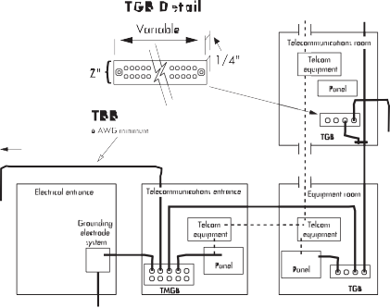

P r odu c t s . Te c hno l ogy . Se r v i c e s . De l i v e r e d Gl ob a l l y.

Fo r mo r e i n f o rma t i on , v i s i t [www.](http://www/) a n i x t e r . c om o r c a l l 1 . 800 . An i x t e r .

StandardsReferenceGuide |63

## ThePurposeofANSI/TIA/EIA-942

##### TelecommunicationsInfrastructureStandardforDataCenters

• Thepurposeofthisstandardistoproviderequirementsandguidelines for thedesignandinstallationofadatacenterorcomputerroom.

* + - Itisintendedfordesignerswhoneedacomprehensiveunderstanding ofthedatacenterdesignincludingthefacilityplanning,thecabling system,andthenetworkdesign.
    - Itfacilitatestheplanningfordatacenterstooccurearlierinthebuilding developmentprocess(architectural,facilities,andIT).

Datacenterssupportawiderangeoftransmissionprotocols.Someofthese protocolsimposedistancerestrictionsthatareshorterthanthoseimposed bythisstandard.Whenapplyingspecifictransmissionprotocols,consult standards,regulations,equipmentvendors,andsystemservicesuppliers forapplicability, limitations,andancillaryrequirements.Considerconsolidating standardizedandproprietarycablingintoasinglestructuredcablingsystem.

###### TheStandardSpecifies:

• Cablingdesign

• Networkdesign

* + - Facilitiesdesign
    - Informativeannexescontaining“bestpractices” andavailabilityrequirements

• Spaces

* + - Pathways

• Racks/cabinets

SectionContents

## ANSI/TIA/EIA-942

TelecommunicationsInfrastructureStandardforDataCenters

DataCenterCablingInfrastructure 66

HotandColdAisles 67

HorizontalCabling 68

BackboneCabling 69

RecognizedCablingMediaforHorizontal andBackboneApplications 70

Redundancy 71

.

r e t

x i n

A

. 0

0

8

. 1

l l a c

r o

m o c

.

r e t

x i n

a

.

w w w

t i s i v

,

n o i t a

m r

o f

n i

e r o m

r o F

64| StandardsReferenceGuide

P r odu c t s . Te c hno l ogy . Se r v i c e s . De l i v e r e d Gl ob a l l y.

StandardsReferenceGuide |65

**DataCenterCablingInfrastructure** Thebasicelementsofthedatacentercablingsystemstructure arethefollowing:

* + - Horizontalcabling
    - Backbonecabling

• Cross-connectintheentranceroomormaindistributionarea

* + - MainCross-Connect(MC)inthemaindistributionarea

• HorizontalCross-Connect(HC)inthetelecommunicationsroom, horizontaldistributionareaormaindistributionarea.

* + - Zoneoutletorconsolidationpointinthezonedistributionarea

• Outletintheequipmentdistributionarea

**HotandColdAisles** Cabinetsandracksshallbearrangedinanalternatingpattern,withfronts ofcabinets/racksfacingeachotherinarowtocreate“hot”and“cold”aisles. Coldaislesareinfrontofracksandcabinets.Ifthereisanaccessfloor,power distributioncablesshouldbeinstalledhereundertheaccessfloorontheslab. Hotaislesarebehindracksandcabinets.Ifthereisanaccessfloor,cabletrays fortelecommunicationscablingshouldbelocatedundertheaccessfloorinthe hotaisles.

Aminimumof1m(3ft)offrontclearanceshallbeprovidedforinstallation ofequipment.Afrontclearanceof1.2m(4ft)ispreferabletoaccommodate deeperequipment.Aminimumof0.6m(2ft)ofrearclearanceshall beprovidedforserviceaccessattherearofracksandcabinets.

Arearclearanceof1m(3ft)ispreferable.Someequipment mayrequireserviceclearancesofgreaterthan1m(3ft).

**Front**

**Thisrowof tilescanbelifted**

|  |  |  |  |  |  |  |
| --- | --- | --- | --- | --- | --- | --- |
|  |  |  |  |  |  |  |
| **Cabinets** | | |
|  |  |  |
|  |  | | **Rear** |  | |  |
| **"HO** | **T"Aisle** | | **(Rearo** | **fCabine** | | **ts)** |
|  |  | | **Rear** |  | |  |
|  |  |  |  |  |  |  |
| **Cabinets** | | |
|  |  |  |
|  |  | | **Front** |  | |  |
| **"COL** | **D"Aisle** | | **(Fronto**  **Front** | **fCabin** | | **ets)** |
|  |  |  |  |  |  |  |
| **Cabinets** | | |
|  |  |  |

**Alignfrontorreadofcabinets withedgeof floortiles**

**Thisrowof tilescanbelifted Thisrowof tilescanbelifted**

**Alignfrontorreadofcabinets withedgeof floortiles**

**HotandColdAisles**

**Rear**

66| StandardsReferenceGuide

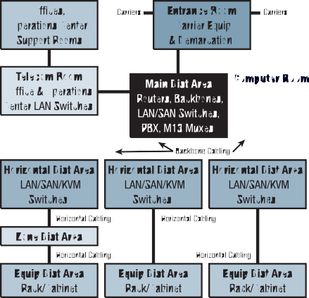

P r odu c t s . Te c hno l ogy . Se r v i c e s . De l i v e r e d Gl ob a l l y.

Fo r mo r e i n f o rma t i on , v i s i t [www.](http://www/) a n i x t e r . c om o r c a l l 1 . 800 . An i x t e r .

StandardsReferenceGuide |67

**HorizontalCabling** Thehorizontalcablingistheportionofthetelecommunicationscabling systemthatextendsfromthemechanicalterminationintheequipment distributionareatoeitherthehorizontalcross-connectinthehorizontal distributionareaorthemaincross-connectinthemaindistributionarea. Thehorizontalcablingincludeshorizontalcables,mechanicalterminations, andpatchcordsorjumpers,andmayincludeazoneoutletoraconsolidation pointinthezonedistributionarea.

Thefollowingpartial listingofcommonservicesandsystemsshould beconsideredwhenthehorizontalcablingisdesigned:

* + - Voice,modemandfacsimiletelecommunicationsservice
    - Premisesswitchingequipment

• Computerandtelecommunicationsmanagementconnections

* + - Keyboard/Video/Mouse(KVM)connections
    - Datacommunications

•WideAreaNetworks(WAN)

* + - LocalAreaNetworks(LAN)

• StorageAreaNetworks(SAN)

• Otherbuildingsignalingsystems(buildingautomationsystems suchasfire,security,power,HVAC,etc.).

**HorizontalCablingUsingStarTopology**

|  |  |  |  |  |
| --- | --- | --- | --- | --- |
|  | **24AWGUTP/24S** | **cTPPatchCords** | **26AWGScTP** | **PatchCords** |
| **Lengthof M**  **HorizontalCable(H) o**  m(ft) m | **aximumLength M fZoneAreaCable(Z) L**  (ft) m | **aximumCombined M engthofZoneArea o Cables,PatchCords andEquipment(C)**  (ft) | **aximumLength M fZoneAreaCable(Z) Le**  **C**  m(ft) m | **aximumCombined ngthofZoneArea ables,PatchCords andEquipmentCable(C)**  (ft) |
| 90(295) 5 | (16) 1 | 0(33) 4 | (13) 8 | (26) |
| 85(279) 9 | (30) 14 | (46) 7 | (23) 1 | 1 (35) |
| 80(262) 13 | (44) 18 | (59) 11 | (35) 1 | 5 (49) |
| 75(246) 17 | (57) 22 | (72) 14 | (46) 1 | 8 (59) |
| 70(230) 22 | (72) 27 | (89) 17 | (56) 2 | 1 (70) |

**BackboneCabling** Thefunctionofthebackbonecablingistoprovideconnectionsbetween themaindistributionarea,thehorizontaldistributionareaandentrance facilitiesinthedatacentercablingsystem.Backbonecablingconsists ofthebackbonecables,maincross-connects,horizontalcross-connects, mechanicalterminationsandpatchcordorjumpersusedforbackbone-to- backbonecross-connection.

**BackboneCablingUsingStarTopology**

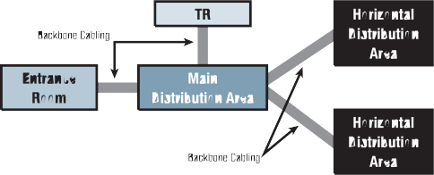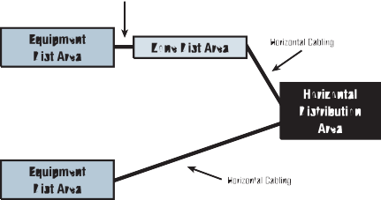

P r odu c t s . Te c hno l ogy . Se r v i c e s . De l i v e r e d Gl ob a l l y.

Fo r mo r e i n f o rma t i on , v i s i t [www.](http://www/) a n i x t e r . c om o r c a l l 1 . 800 . An i x t e r .

68| StandardsReferenceGuide

StandardsReferenceGuide |69

**RecognizedCablingMediaforHorizontalandBackboneApplications** Recognizedcables,associatedconnectinghardware,jumpers,patchcords, equipmentcordsandzoneareacordsshallmeetallapplicablerequirements specifiedinANSI/TIA/EIA-568-B.2andANSI/TIA/EIA-568-B.3.

* + - 100ohmtwisted-paircable(ANSI/TIA/EIA-568-B.2), Category6recommended(ANSI/TIA/EIA-568-B.2-1)

• Multimodeopticalfibercable,either62.5/125µor50/125

µ (ANSI/TIA/EIA-568-B.3),50/125µ850nmlaseroptimized multimodefiberisrecommended(ANSI/TIA-568-B.3-1)

• Single-modeopticalfibercable(ANSI/TIA/EIA-568-B.3).

• Therecognizedcoaxialmediaare75ohm(734and735type) coaxialcable(TelcordiaTechnologiesGR-139-CORE)andcoaxial connector(ANSIT1.404).

**Redundancy** Datacentersthatareequippedwithdiversetelecommunicationsfacilities maybeabletocontinuetheirfunctionundercatastrophicconditions thatwouldotherwiseinterruptthedatacenter’stelecommunicationsservice. Thisstandardincludesfourtiersrelatingtovariouslevelsofavailabilityofthe datacenterfacilityinfrastructure.Thetiersarerelatedtoresearchconducted bytheUptimeInstitute,whichdefinefourtiersofperformanceasdefined inthefollowingtable.

70| StandardsReferenceGuide

P r odu c t s . Te c hno l ogy . Se r v i c e s . De l i v e r e d Gl ob a l l y.

Fo r mo r e i n f o rma t i on , v i s i t [www.](http://www/) a n i x t e r . c om o r c a l l 1 . 800 . An i x t e r .

|  |  |  |  |  |
| --- | --- | --- | --- | --- |
|  | **Tier I: Basic** | **Tier II: Redundant Components** | **Tier III: Concurrently Maintainable** | **Tier IV: Fault Tolerant** |
| **Numberof**  **Deliverypaths**  Redundant Components | **Only1**  N | **Only1**  N+1 | **1Active,1Passive**  N+1 | **2Active**  2(N+1)S+S |
| SupportSpace toRaised FloorRatio | 20% | 30% | 80-90% | 100% |
| InitialWatts/ft | 20-30 | 40-50 | 40-60 | 50-80 |
| UltimateWatts/ft | 20-30 | 40-50 | 100-150 | 150+ |
| RaisedFloor Height | 12” | 18” | 30-36” | 30-36” |
| FloorLoading Pounds/ft | 85 | 100 | 150 | 150+ |
| UtilityVoltage | 208,480 | 208,480 | 12-15kV | 12-15kV |
| Months toImplement | 3 | 3to6 | 15to20 | 15to20 |
| YearFirst Deployed | 1965 | 1970 | 1985 | 1995 |
| Construction$/ft RaisedFloor | $450 | $600 | $900 | $1,100+ |
| AnnualIT DowntimeDue toSite | 28.8hrs | 22.0hrs | 1.6hrs | 0.4hrs |
| SiteAvailability | 99.671% | 99.749% | 99.982% | 99.995% |

StandardsReferenceGuide |71

Providingredundantcross-connectareasandpathwaysthatarephysically separatedcanincreasethereliabilityofthecommunicationsinfrastructure. Itiscommonfordatacenterstohavemultipleaccessprovidersproviding services,redundantrouters,redundantcoredistributionandedgeswitches. Althoughthisnetworktopologyprovidesacertainlevelofredundancy, theduplicationinservicesandhardwarealonedoesnotensure thatsinglepointsoffailurehavebeeneliminated.

## Purposeof theISO11801:2002Standard

###### TheInternationalStandardprovides:

• Userswithanapplicationindependentgenericcablingsystem capableofsupportingawiderangeofapplications

• Userswithaflexiblecablingschemesothatmodifications arebotheasyandeconomical

* + Buildingprofessionals(forexamplearchitects)guidanceonthe accommodationofcablingattheinitialstagesofdevelopment

###### TheInternationalStandardspecifiesamultivendorcablingsystem whichmaybeimplementedwithmaterial fromsingle andmultiplesources,andisrelatedto:

* + Internationalstandardsforcablingcomponentsdeveloped bycommitteesintheIEC.

• Standardsfortheinstallationandoperationofinformation technologycablingaswellasfortestingofinstalledcabling

* + ApplicationsdevelopedbytechnicalcommitteesoftheIEC
  + Planningandinstallationguideswhichtakeintoaccount theneedsofspecificapplications

###### GenericcablingdefinedwithinthisInternationalStandard:

• Specifiesacablingstructuresupportingawidevarietyofapplications

• SpecifieschannelandlinkclassesA,B,C,DandEmeetingtherequirements ofstandardizedapplications

• SpecifieschannelandlinkclassesEandFbasedonhigherperformance componentstosupportfutureapplications

• SpecifiesopticalchannelandlinkclassesOF-300,OF-500andOF-2000

* + Involvescomponentrequirementsandspecifiescablingimplementations thatensureperformanceofpermanentlinksandchannelsthatmeet orexceedtherequirementsforcablingclasses

TheInternationalStandardspecifiesagenericcablingsystemthat isanticipatedtohaveausablelifeinexcessof10years.

P

r o d u c t s

.

T

e c h n o

l o g y

.

S

e r v i c e s

.

D

e l i v

e r e d

G

l o b a l l y

.

StandardsReferenceGuide |73

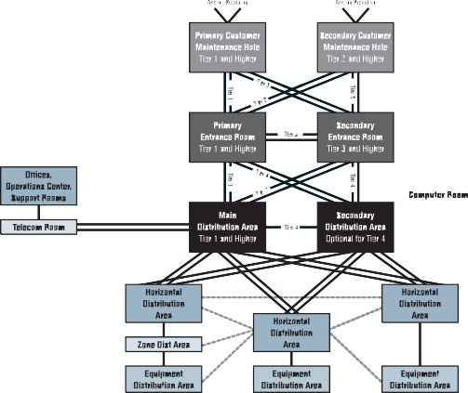

Fo r mo r e i n f o rma t i on , v i s i t [www.](http://www/) a n i x t e r . c om o r c a l l 1 . 800 . An i x t e r .

72| StandardsReferenceGuide

P

r o d u c t s

.

T

e c h n o

l o g y

.

S

e r v i c e s

.

D

e l i v

e r e d

G

l o b a l l y

.

StandardsReferenceGuide |75

Fo r mo r e i n f o rma t i on , v i s i t [www.](http://www/) a n i x t e r . c om o r c a l l 1 . 800 . An i x t e r .

## ISO11801ClassEAStandard

**TheAnixterEuropeanStandardsReferenceGuide**

TheAnixterEuropeanStandardsReferenceGuideisaninvaluableindustry tooltohelpyoustayinformedofrecentdevelopmentsinstandardsfor structuredcablingsystems.Theguideincludesanup-to-datesummary oftheANSI/TIA/EIA,ISO,CENELECandIEEEstandardsfeaturingEuropean standardsISO11801,ISO18010,EN50173,EN50174,EN50310.

Toorderacopy,goto[www.anixter.com/literature.](http://www.anixter.com/literature)

ThedraftrequirementsforISO(TheInternationalOrganization forStandardization)ClassEAaremoredemandingcomparedtoTIA/EIA AugmentedCat6draftrequirements.Anixter’slabteststothemorestringent ISOdraftstandards.

## IEEE’s802.3afPoweroverEthernet(PoE)Standard

|  |
| --- |
| **ISOComparedtoTIA** |
| **Characteristics500MHz(dB) ISOClassEA TIAAugmentedCat6Draft**  PSNEXTLoss 24.8dB 23.2dB |
| NEXTLoss 27.9dB 26.1dB PSANEXTLoss 49.5dB 49.5dB |
| ReturnLoss 8.0dB 6.0dB |
| InsertionLoss 49.3dB 49.3dB ReferredtobyIEEE Yes No |

TheIEEE’s802.3afspecificationcallsforpowersourceequipment(PSE), whichoperatesat48voltsofdirectcurrent.Thisguarantees12.95watts ofpoweroverunshieldedtwisted-paircabletodataterminalequipment(DTE) 100metersaway(themaximumdistancesupportedbyEthernet).That’senough powertosupportIPphones,WLANaccesspointsandmanyotherDTEdevices. TwoPSEtypesaresupportedincludingEthernetswitchesequippedwithapower supplymodulecalledend-spandevicesandaspecialpatchpanelcalled amidspandevice,thatsitsbetweenalegacyswitchandpoweredequipment, injectingpowertoeachconnection.

|  |
| --- |
| **TIACategory6versusAugmentedCategory6versusISOClassEA** |
| **TIACategory TIACategory TIAAugmented ISOClassEA 5eUTP 6UTP Category6UTP**  Recognized  byIEEE802.3an No Yes Yes Yes |
| 55Meter  DistanceSupport No Yes Yes Yes |
| 100Meter  DistanceSupport No No Yes Yes ExtrapolatedTest  LimitsforNEXT  andPSNEXT  to500MHz No No No Yes |

ThistablesummarizesthevariousUTPcablingoptionsandtheirrespective 10Gigabitperformanceattributesasdefinedbythelatestdraftstandards. Category5eisnotrecognizedasaviablecablingmediatosupport10Gigabit transmissionregardlessofitsinstalledcablingdistance.Category6cabling willonlysupport10Gigabitatamaximuminstalleddistanceof55meters. Today,theonlyoptionsforoperating10Gigabitat100metersaretheTIA AugmentedCategory6andISOClassEAstandards.ISO’sClassEAsystem hassuperiorreturnloss,NEXTandPSNEXTperformancevalueswhen comparedwiththecurrentTIAAugmentedCategory6draftproposals.

74| StandardsReferenceGuide

## IEEE’s802.11WirelessStandard

**IEEE802.11**, theWi-Fistandard,denotesasetofwirelessLAN/WLAN standardsdevelopedbyworkinggroup11oftheIEEELAN/MANstandards committee(IEEE802).Theterm802.11xisalsousedtodenotethisset ofstandards,andisnottobemistakenforanyoneofitselements.

Thereisnosingle802.11xstandard.

802.11detailsawirelessinterfacebetweendevicestomanagepackettraffic (toavoidcollisions,etc.).Somecommonspecificationsandtheirdistinctive attributesincludethefollowing:

**802.11a**–Operatesinthe5GHzfrequencyrange(5.125to5.85GHz) withamaximum54Mbpssignalingrate.The5GHzfrequencyband isn’tascrowdedasthe2.4GHzfrequencybecauseitofferssignificantly moreradiochannelsthanthe802.11bandisusedbyfewerapplications. Ithasashorterrangethan802.11g,isactuallynewerthan802.11b andisnotcompatiblewith802.11b.

**802.11b**–Operatesinthe2.4GHzindustrial,scientificandmedical(ISM) band(2.4to2.4835GHz)andprovidessignalingratesofupto11Mbps. Thisisaverycommonlyusedfrequency.Microwaveovens,cordlessphones, medicalandscientificequipment,aswellasBluetooth ® devices,allwork withinthe2.4GHzISMband.

**802.11e**–RatifiedbytheIEEEinlateSeptemberof2005,the802.11e quality-of-servicespecificationisdesignedtoguaranteethequality ofvoiceandvideotraffic.Itwillbeparticularlyimportant forcompaniesinterestedinusingWi-Fiphones.

**802.11g**–Similarto802.11b,butthisstandardsupportssignaling ratesofupto54MbpsItalsooperatesintheheavilyused2.4GHzISM bandbutusesadifferentradiotechnologytoboostoverallthroughput. Compatiblewitholder802.11b.

**802.11i** –AlsosometimescalledWi-FiProtectedAccess2(WPA2), 802.11iwasratifiedinJune2004.WPA2supportsthe128-bit-and-above AdvancedEncryptionStandard,alongwith802.1xauthenticationandkey managementfeatures.

**802.11k**–Predictedforratificationinmid-2007,the802.11kRadio ResourceManagementStandardwillprovidemeasurementinformation foraccesspointsandswitchestomakewirelessLANsrunmoreefficiently. Itmay,forexample,betterdistributetrafficloadsacrossaccesspoints orallowdynamicadjustmentsoftransmissionpowertominimize interference.

**802.11n**–TheStandardforEnhancementsforHigherThroughput isdesignedtoraiseeffectiveWLANthroughputtomorethan 100MbpsFinalratificationisexpectedinlate2007.

76| StandardsReferenceGuide

P r odu c t s . Te c hno l ogy . Se r v i c e s . De l i v e r e d Gl ob a l l y.

Fo r mo r e i n f o rma t i on , v i s i t [www.](http://www/) a n i x t e r . c om o r c a l l 1 . 800 . An i x t e r .

StandardsReferenceGuide |77

## IEEE802.3anStandard

|  |  |  |  |
| --- | --- | --- | --- |
| **IEEE802.3anStandard** | | | |
| **IEEEModel** | **Standard** | **Media** | **Distance** |
| 1 | ISOClassF | S/FTP | 100m |
|  | (individualshields) |  |  |
| ISOClassEA | | UTP | 100m |
| TIAAugmentedCat6 | | UTP | 100m |
| 2,3,4 | ShieldedCat6 | F/UTP,ScTP,STP | 100m |
|  | (overallshield) |  |  |
| TIAStandardCat6/ | | UTP | <55m |
| ISOClassE | |  |  |

ANSI/EIA/TIA-568-B.2-ad10(AugmentedCategory6)andISO11801(ClassEA) cablespecificationsarebasedonIEEEmodels.

TheIEEEcreatedfourmodels,whichspecifydistancelimitationsbased onmediatypes.

100metersoverUTPisonlyguaranteedwhenusingAugmentedCategor y6or ISOClassEAcompliantcablingsystems.

Fo r mo r e

###### TIA-568-B.2-ad10AugmentedCat6orISO11801ClassEAcables.

**10GigabitEthernetChannelApplications**

**Application 10GBaseFiber(802.3ae) 10GBase-T 10GBase-CX4(802.3ak)**

DataCenter Yes Yes Yes(<15m) (ServerClustering)

Horizontal(InBuilding) No Yes No Vertical(Risers) Yes No No Campus/Metro Yes No No

Inthechartabove,therecommendedapplicationroadmapsfor10Gigabit Ethernetcablingandprotocoltypeshavebeenprovided.Thechoiceofwhich mediatousewillrevolvearoundthreevariables:

•Circuitdistances

•Cost

•Activeequipmentinterfaces(connectors).

10GBASEFiberwillmaintaintraditionalapplicationinbackbones andrisersandalsointhedatacenterforserverclustering.

10GBASE-Tcopperwillremaininthetraditionalareasofapplication (inhorizontalbuildingcablingbutalsointhedatacenterbetween serversandclusters).

c a l l

1 . 800 . An i x t e r .

10GBASE-CX4definesamulti-conductorcoppersolutionprimarilydesigned toconnectserversandswitchesovershortdistances.

i n f o rma t i on ,

v i s i t [www.](http://www/) a n i x t e r . c om o r

78| StandardsReferenceGuide

P r odu c t s . Te c hno l ogy . Se r v i c e s . De l i v e r e d Gl ob a l l y.

Fo r mo r e

i n f o rma t i on ,

v i s i t [www.](http://www/) a n i x t e r . c om o r

c a l l

1 . 800 . An i x t e r .

StandardsReferenceGuide |79

## Anixter’sEnterpriseCablingandSecurityLabs

AtAnixter,makingsureourcustomershavethemostcurrentandaccurate informationtoselecttherightproductsfortheirspecificapplications isparamounttous.Weownandoperatetwolabs,theUL ®–certified EnterpriseCablingLabandtheSecurityLab,specificallytoevaluate andtestawiderangeofemergingnewproductsandtechnologiesbeing developedandmarketed.Ourlabsgiveourcustomerstheabilitytopreview howtheirnewproductswillactuallyperformbeforepurchasingthem.

###### EnterpriseCablingLabTesting:

•RandomperformancetestingofAnixterinventory toensurequalityofstandardscompliance

•Networkthroughputandinteroperabilitytesting

•Copperandfibercablingcomplianceverification(TIA/EIA,ISO/IEC,IEEE)

•Customerproofofconcept

•PoweroverEthernet(PoE)

•Applicationtesting

###### SecurityLabTesting:

•VideooverIP,videoqualityandbandwidthutilization

•PoweroverEthernet(PoE)capabilityverification

•Digitalcompressionimagequalityvs.analogtechnologytesting

•EvaluationofanalogandIPcameras,videomanagement softwareevaluation,DVR,NDVRandNVRproducts

###### BusinessDriversAffectingthePurchase ofEnterpriseCablingProducts:

•Newapplications

•Higherbandwidthrequirements

•Convergence

•Maintaincompetitiveedge

•Costofmoves,adds,andchanges(MACs)

•Businessprocessefficiencies

###### BusinessDriversAffectingthePurchaseSecurityProducts:

•ConvergenceofITandsecurity

•Analogtodigitaltechnologyshift

•Lossprevention

•Systemsintegration

•Preventativesecurityprecautions

•Assetprotection

**Anixter’sEnterpriseCablingandSecurityLabsInAction**

###### Problem:LeadingPennsylvaniaUniversityExplores Campus-wideRewiringProject

**AnixterEnterpriseCablingLabSolution:** TheAnixterEnterpriseCablingLab wascalledupontohelpthisuniversitydeterminewhichcoppercablingsystem wouldbestmeettheircurrentandfutureinformationtechnologyneeds.

Theuniversityhadavarietyofdifferentcoppercablingproductsinstalled intheirnetworkinfrastructure–Category3,Category5andsomeCategory5e. TheAnixterEnterpriseCablingLabdeployedcomputerapplicationsthat theuniversitytypicallycarriedovertheircablinginfrastructureincludingLotus Notes,SAPandstreamingvideo.Testingfoundthattheircurrentinfrastructure wasconsistentlydroppinginformationcausingthenetworktooperateslowly andinefficiently.ThissametrafficwassentoveraCategor y6infrastructure withnodegradationtothedata.ArmedwithtestingfromtheAnixterEnterprise CablingLab,universityITprofessionalswrotecablinginfrastructure specificationsaroundahigherperformingCategory6systemthatbetter

mettheuniversity’snetworkperformanceneeds.

80| StandardsReferenceGuide

P r odu c t s . Te c hno l ogy . Se r v i c e s . De l i v e r e d Gl ob a l l y.

Fo r mo r e i n f o rma t i on , v i s i t [www.](http://www/) a n i x t e r . c om o r c a l l 1 . 800 . An i x t e r .

StandardsReferenceGuide |81

###### Problem:MajorRailwayCompanyNeedsVideoSurveillance ToMonitorSwitchyard

**AnixterSecurityLabSolution:**Thisrailroadwantedtousevideosurveillance tomonitoryardsastheyassembledunittrains,buthadabigcablingchallenge infrontofthem.Installingtraditionalcablingintheswitchyardwouldhave entailedmajordisruptionsandexpenseforthecustomer .TheAnixterSecurity Labrecommendedasophisticatedwirelessinternetvideosurveillancesystem thatdidnotrequirecabling.Anixterwasabletosimulatethewirelessinternet videosurveillancesolutionintheSecurityLabforthecustomer .TheSecurity Labalsoprovidedthiscustomerwithtestresultsillustratinghowmuch bandwidththevideosolutionwouldabsorbonthecustomer’snetworkaswell asthevideoqualitythecustomercouldexpectfromtherecommendedsystem.

###### Problem:National InsuranceCompany withDataCenterCablingChoice

**AnixterEnterpriseCablingLabSolution:** TheAnixterEnterpriseCabling Labassessedbackbonecablingrequirementsbasedonthecurrentandfuture bandwidthneedsforthisinsuranceprovider.TheAnixterEnterpriseCablingLab ranrepresentativenetworktrafficover62.5,50-micronandlaser-optimized 50-micronfiber(LOMF)toascertainwhichwouldbestmeettheirneeds.These testswerekeyindeterminingthattheLOMFwasthecustomer’sbestchoice.

**Anixter’s10GigEthernetCablingTesting** AnixterEnterpriseCablingLabistheonlyUL-certifiedlabtoconduct rigorous,independentthirdpartytestingoftheemerging10Gigcabling solutions.Anixter’s10Gigcablingtestingexamineselectricalcharacteristics suchasinsertionloss,returnloss,andcrosstalk,butalsolooksatalien crosstalk(whichispartoftheAugmentedCat6draftspec.)Toensurethat the10Gigcablingsolutionswesellmeetthehighestlevelsofperformance andreliabilityforourcustomers,theAnixterEnterpriseCablingLabteststhe toughestperformanceparameter,aliencrosstalk,inthe“worstcase”scenario. YoucanrestassuredthatthecablingsolutionsAnixtersellswillprovide thenetworkperformanceyourequire.

82| StandardsReferenceGuide

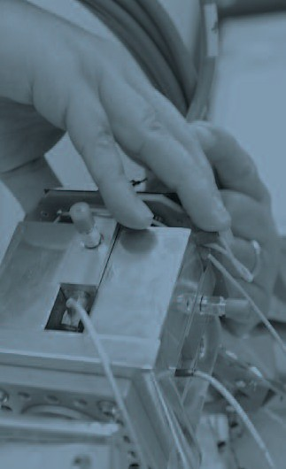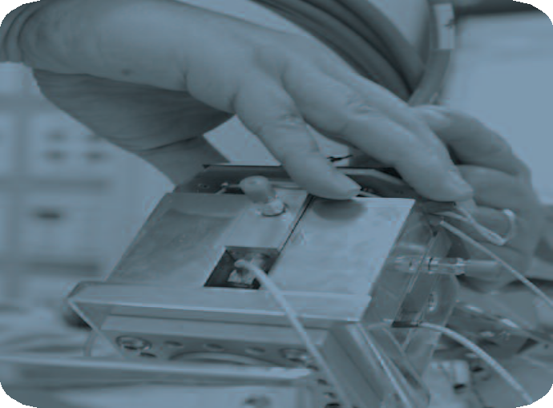

P r odu c t s . Te c hno l ogy . Se r v i c e s . De l i v e r e d Gl ob a l l y.

Fo r mo r e i n f o rma t i on , v i s i t [www.](http://www/) a n i x t e r . c om o r c a l l 1 . 800 . An i x t e r .

StandardsReferenceGuide |83

###### ReferenceDocumentsforFurther InformationonCablingStandards TIA/EIA-568-B.1(2001)

CommercialBuildingTelecommunicationsCabling

StandardPart1:GeneralRequirements

**TIA/EIA-568-B.2**(2001)

CommercialBuildingTelecommunicationsCabling StandardPart2:BalancedTwistedPairCablingComponents

**TIA/EIA-568-B.2-1**(2002)

TransmissionPerformanceSpecificationsfor4-pair100

AugmentedCategory6Cabling

**TIA/EIA-568-B.2-ad10**(Draft)

TransmissionPerformanceSpecificationsfor4-pair100

AugmentedCategory6Cabling

**TIA/EIA-568-B.3**(2000)

OpticalFiberCablingComponentsStandard

**TIA/EIA-569-B**(2004) (CSAT530)*

CommercialBuildingStandardforTelecommunicationsPathwaysandSpaces

**TIA/EIA-570-A**(1999) (CSAT525)*

ResidentialandLightCommercialTelecommunicationWiringStandard

**TIA/EIA-606-A**(2002) (CSAT528)*

AdministrationStandardfortheTelecommunicationsInfrastructure ofCommercialBuildings

**J-STD-607-A**(2002) (CSAT527)*

CommercialBuildingGrounding/BondingRequirementsforTelecommunications

*CanadianStandardsAssociationequivalentdocument

**TIA/EIA-758**(1999)

Customer-ownedOutsidePlantTelecommunicationsCablingStandard

**TIA/EIA-942**(2005)

TelecommunicationsInfrastructureStandardforDataCenters

**IS0/IEC11801**(2002)

GenericCablingforCustomerPremises

**IEEE802.3-1998**(1998)

CarrierSenseMultipleAccesswithCollisionDetection(CSMA/CD) AccessMethodandPhysicalLayerSpecification(alsoknown asANSI/IEEEStd802.3-1998orISO8802-3:1990(E))

**IEEE802.3an**(2006)

PhysicalLayerandManagementParametersfor10Gb/sOperation, Type10GBase-T

**IEEE802.5-1998**(1998)

TokenRingAccessMethodandPhysicalLayerSpecifications (alsoknownasANSI/IEEEStd802.5-1998)

P r odu c t s . Te c hno l ogy . Se r v i c e s . De l i v e r e d Gl ob a l l y.

Fo r mo r e i n f o rma t i on , v i s i t [www.](http://www/) a n i x t e r . c om o r c a l l 1 . 800 . An i x t e r .

84| StandardsReferenceGuide

StandardsReferenceGuide |85

###### ObtainingStandardsDocuments

TIA/EIAdocumentsmaybepurchasedthroughGlobalEngineering Documentsat1-800-854-7179or[www.global.ihs.com.IEEEdocuments](http://www.global.ihs.com.IEEEdocuments/) maybepurchasedthroughIEEE,P.O.Box1331,Piscataway,NJ08855 or[www.ieee.org.CSAdocumentsmaybepurchasedthroughtheCanadian](http://www.ieee.org.CSAdocumentsmaybepurchasedthroughtheCanadian/) StandardsAssociationatwww.csa.caorbycalling(416)747-4000.

Forfurtherassistanceormoreinformation,contactyourlocalAnixtersales officeor1-800-ANIXTER.Somematerial inthispublicationisreproduced fromstandardspublicationswhicharecopyrightedbytheTelecommunications IndustryAssociation.

ThishandbookwaspreparedbyAnixterInc.,whichisnotaffiliatedwiththe TelecommunicationsIndustryAssociationortheElectronicIndustriesAlliance. NeitherEIAnorTIAareresponsibleforthecontentofthispublication.

Fordirectassistanceininterpretingtelecommunicationsstandards, considerRegisteredCommunicationsDistributionDesigners(RCDD) certifiedbytheBuildingIndustryConsultingServiceInternational(BICSI) at(800)242-7405or[www.bicsi.org.HundredsofAnixtertechnical](http://www.bicsi.org.HundredsofAnixtertechnical/) professionalsareregisteredwithBICSI.

## TheAnixterEuropeanStandardsReferenceGuide

TheAnixterEuropeanStandardsReferenceGuideisaninvaluableindustry tooltohelpyoustayinformedofrecentdevelopmentsinstandardsfor structuredcablingsystems.Theguideincludesanup-to-datesummary oftheANSI/TIA/EIA,ISO,CENELECandIEEEstandardsfeaturingEuropean standardsISO11801,ISO18010,EN50173,EN50174,EN50310.

Toorderacopy,goto[www.anixter.com/literature.](http://www.anixter.com/literature)

86| StandardsReferenceGuide

P r odu c t s . Te c hno l ogy . Se r v i c e s . De l i v e r e d Gl ob a l l y.

Fo r mo r e i n f o rma t i on , v i s i t [www.](http://www/) a n i x t e r . c om o r c a l l 1 . 800 . An i x t e r .

StandardsReferenceGuide |87

EnterpriseCablingandSecuritySolutions • Electricaland ElectronicWire&Cable • Fasteners • SupplyChainServices AnixterInc. • 1.800.ANIXTER • anixter.com • WorldHeadquarters: 2301PatriotBoulevard,Glenview, IL60026-8020• 224.521.8000

AnixterInc. istheworld’sleadingsupplierofSupplyChainServicesandproductsused toconnectvoice,video,dataandsecuritysystems.Anixter isalsotheleadingproviderofspecialty electricalandelectronicwireandcableforbuildingconstruction, industrialmaintenanceandrepair, andoriginalequipmentmanufacturing,aswellastheleader inprovidingfastenersand“C”Class componentstoOEMsandproductionlines.Webundleourproductswithour innovativeSupplyChain Servicestohelpcontrol thecostofourcustomers’businessprocesses,reducetheir investment ininventory,andensuretheyget therightproductwhentheyneedit.Apubliclyheldcompany, Anixter,withitssubsidiaries,servescompaniesinmorethan45countriesaroundtheworld.

Anixter’stotal revenueexceeds$3.8billion.

AnixterInc.doesnotmanufacturetheitemsdescribedinthispublication.Allapplicablewarranties areprovidedbythemanufacturers.Purchasersarerequestedtodeterminedirectlyfromthemanufacturers theapplicableproductwarrantiesandlimitations.Dataandsuggestionsmadeinthepublication

6W0001Z1 © 2006Anixter Inc. • 10/06 • 5K • 251937

arenot tobeconstruedasrecommendationsorauthorizationstouseanyproductsinviolation ofanygovernment laworregulationrelatingtoanymaterialor itsuse.